Analytics Series

Vol 1, No 5. What is Analytics? Definition and Essential Characteristics
By Adam Cooper (CETIS)

What is Analytics? Definition and Essential Characteristics
Adam Cooper (CETIS)

Table of Contents
1. Introduction 3
2. A Definition of “Analytics”? 3
2.1 What are “Actionable Insights”? 4
3. Three Domains of Analytics 5
4. Summary – The Essential Characteristics of Analytics 7
5. Recommended Reading 7
6. References 8
About this White Paper 10
About CETIS 10

Introduction
There is currently a growing interest in better exploiting data from various sources to help organisations to be more effective and a growing number of strategies for doing this are being developed across different industries. The term “analytics” is frequently being applied to these efforts but often without clarity as to what the word is intended to mean. This makes it difficult to make sense of what is happening or to decide what to appropriate from other industries or research and hinders creative leaps forward in exploring how to adopt analytics.
This paper, part of the CETIS Analytics Series, is aimed at strategists and innovators in post-compulsory education sector who are grappling with these questions in the context of a single institution or the sector at large. It does so by:
- considering a definition of “analytics”; and
- outlining analytics in relation to research management, teaching and learning or whole-institution strategy and operational concerns.

A Definition of “Analytics”?
The problem with defining any buzz-word, including “analytics” is that over-use and band-wagon jumping reduces the specificity of the word. This problem is not new [1] and any attempt to create a detailed definition seems to be doomed, no matter how careful one might be, because there will always be someone with a different perspective or a personal or commercial motivation to emphasise a particular aspect or nuance. The rather rambling Wikipedia entry for analytics illustrates this difficulty.
A recent paper from the EDUCAUSE Learning Initiative [2] starts from a similar observation in the particular context of Higher Education, noting in its abstract that “preliminary review of the analytics in education and practitioner literature revealed similar terms with different conceptual or functional definitions, as well as different terms with similar conceptual or functional definitions”. This paper notes that analytics is applied to both conceptual and functional distinctions (i.e. what it is and what it does). Other writers have also explored definition and process together, for example [3] in relation to “learning analytics”.
The EDUCAUSE paper collates a number of definitions of key terms before advancing a “converged set of definitions” (their words). They propose analytics is understood as “an overarching concept that is defined as data-driven decision making”. The idea of an overarching concept rather than a detailed definition is the approach taken up for our definition but we avoid two ideas that are hinted at by “data-driven decision making”, although they may not have been intended by Barneveld et al: 1) that analytics is just about decision-making rather than being inclusive of exploration and problem definition; 2) that action is driven by data rather than being informed from data.
Hence, rather than adopt this definition, these two potential restrictions are softened and the idea of “actionable insights” is substituted for the idea of decision-making and the definition is extended to include problem formulation in the scope of “analytics”. Our definition of analytics, although it might better be called a description, emphasises analytics as something people do:
Analytics is the process of developing actionable insights through problem definition and the application of statistical models and analysis against existing and/or simulated future data.

What are “Actionable Insights”?
“Actionable” indicates that analytics is concerned with the potential for practical action rather than either theoretical description or mere reporting. It implies that the conclusion of the analytics process may lead a rational person to follow different courses of action according to their values and factors not accounted for in the analysis (e.g. for which data is missing or unobtainable). It also implies that conclusions are qualified with measures of their validity or reliability - such as statistical significance or confidence level, an acknowledgement of limitations or bias, etc - since these are necessary to judge whether action is warranted or not. Too frequently, management reports fail to provide this level of clarity and leave actionable insights as missed opportunities.
Two examples should make the meaning of “actionable insight” more clear.

Example 1: A/B Testing Web-sites
High-volume eCommerce sites such as Amazon and eBay, political campaigns and many others with large numbers of visitors have, in recent years, adopted an incremental approach to web-site design based on testing small variations with users [4]. Visitors are selected at random and either shown version A or version B, which might be a different placement of a checkout icon or a different colour background, and a meaningful statistic such as sale-completion is compared between the variants. Given a proper statistical treatment this leads to a design decision with known and desirable outcomes and which may well go against instinct or design convention: an actionable insight.

Example 2: Customer Incentives
Consider the case where a Broadband customer has failed to renew their contract or calls to cancel. The service provider would like to offer incentives to retain that customer and will use analytics to estimate the customer’s life-time revenue and to understand what kind of incentive will work for them so that the call-centre employee can make an appropriate special offer. Back-office data analysts continually strive to build more effective models of user behaviour with better per-customer performance, which is ultimately delivered to front-line staff as a recommended action tailored to the customer they are dealing with.
These examples illustrate an important distinction we wish to make between analytics and the historical practice of management reporting or Business Intelligence: the broadly scientific attitude of analytics and the importance of problem definition. Problem definition may sometimes be captured in software designed for end-users or it may be tackled in ad hoc analytics by a process of exploration and refinement from a general question to specific questions.
This kind of exploratory process means that the questions expressed in terms of the real-life context must be translated to statistical questions and ultimately to data-processing decisions. This is likely to be a non-trivial exercise requiring knowledge of both the problem domain and technical methods as well as consultation with stakeholders for whom any candidate insight must be meaningful to be actionable.

Making End-of-module Feedback More Actionable
Surveys of student satisfaction and experience at the end of a module (course) are ubiquitous in post-compulsory education but too often they fail as a mechanism for curriculum change because they lack the design and execution that is necessary to expose strong enough evidence. Averages and pie charts (etc) for each of a range of questions are generally inadequate to support a compelling case for change and staff questions arising from these summary statistics generally remain unanswered because the report represents the end of a process. What kind of approach would bring these kinds of survey into the scope of analytics as defined above?
Some progress can be made by more use of conventional statistical tests that can show how likely (or otherwise) it is that differences are due to random variation in the cohort. More insight might be gained by looking for correlation between student background, levels of participation, satisfaction with student support services, module combinations, achievement, demographics etc and satisfaction ratings. Even given this level of analysis, there may still be too many unanswered questions unless the questionnaire is seen as only one instrument in an ongoing action-research activity rather than being a summative survey. For complex processes such as education, we should not expect insight to be gained straight away.
For many educational establishments, becoming more analytical will require the development of organisational capability and a set of appropriate skills and literacies [5]. The institutional benefit is awareness of opportunities for quality enhancement that would otherwise have been missed, while individuals may also gain less tangible rewards. Institutions like the UK Open University have tacked the problem by establishing a Student Surveys and Statistics Team, which undertakes targeted research projects in addition to providing standard reports and dashboard presentations of key performance data. Such kind of unit is likely to be close to the strategic heart of successful adopters of analytics.

Three Domains of Analytics
Writers about analytics have used or coined various qualifications to the term such as “web analytics”, “consumer analytics” or “business analytics” according to their chosen emphasis. Can we usefully discriminate between kinds of analytics in post-compulsory education? The EDUCAUSE paper “Analytics in Higher Education: Establishing a Common Language” [2] addresses this question and defines both “academic analytics” and “learning analytics” - a separation that matches well two largely-distinct groups of stakeholders - by induction from actual usage of these terms. The following three paragraphs consider their definitions.
For Learning Analytics, an objective of “support[ing] the achievement of specific learning goals” is embedded in the definition but this appears to prejudicially exclude the use of analytics to support reflection by learners on their learning experience including the identification of unintended learning gains. Since we are at an immature stage of discovering what the affordances, and also the limitations, of analytics is in relation to teaching and learning, it might be better to avoid this restriction while noting that much software currently being developed and announced under the banner of “learning analytics” is oriented towards the objective of supporting the achievement of specific learning goals.
Their proposed definition of Academic Analytics refers to “operational and financial decision making” and elsewhere in the paper there are comments that this is a parallel concept to Business Analytics; essentially it deals with the matters that a business person who is responsible for an Academy would be most interested in. A more inclusive definition should properly include strategy in addition to operational concerns.
Finally, the definitions in the EDUCAUSE paper do not explicitly consider the role of analytics in relation to research management, although it is implicitly part of Academic Analytics through reference to the SPEAR project. It may be helpful to tease these stereotypes apart, not least on the grounds that the stakeholder groups are not identical, so this paper introduces a third domain, which might be called “Research Management Analytics” and which excludes analytical practices within research disciplines. As such, it blends into Academic Analytics while also including elements with a supra-institutional scope.
Hence, despite the best efforts of Barneveld et al to identify definitions from an emerging common language, we are uncomfortable with the definitions they advance while also being equally convinced that attempts at an alternative definition would be no better. For the purposes of this paper and other papers in the CETIS Analytics Series (see “Recommended Reading”), therefore, three overlapping and interacting domains of analytics are proposed, illustrated in the following diagram (Figure 1). Rather than being defined, the domains are loosely described through example and stakeholder stereotypes. The EDUCAUSE paper definitions are special cases included within these domains.
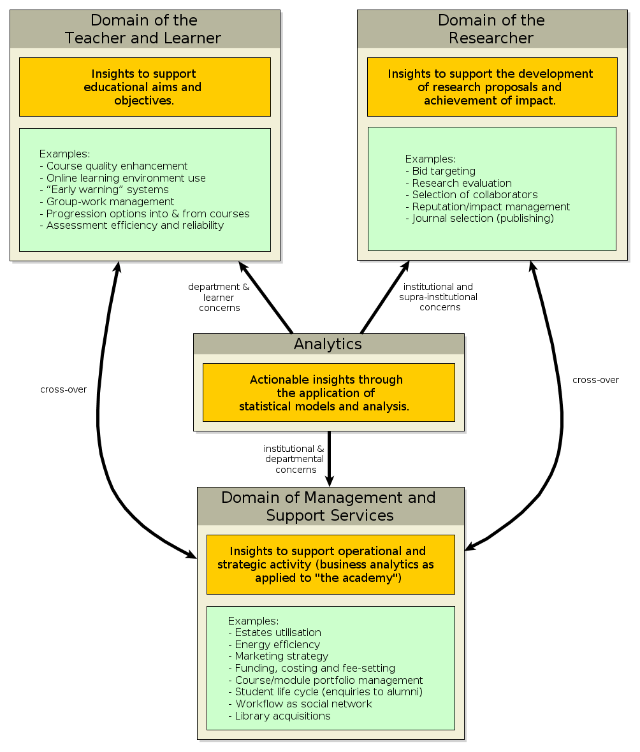
Figure 1: Three Broad Domains of Analytics by Example.
A subsequent paper to this one, discussing a Framework of Characteristics [6], continues this approach, describing rather than naming, by exploring what analytics means through the lens of the relationship between people, methods, models and things that are the subjects and objects of analysis. It is hoped that this will allow us to develop our understanding of what analytics is as we gain experience of it.

Summary: The Essential Characteristics of Analytics
The purpose of this paper is to explore the meaning of analytics and to identify its essential characteristics. Rather than giving detailed in definitions, a broad but distinctive definition of analytics was proposed to be:
“Analytics is the process of developing actionable insights through problem definition and the application of statistical models and analysis against existing and/or simulated future data.”
The emphasis on actionable insights and a scientifically-inclined process of problem definition and exploration points to what the author considers to be those essential characteristics of analytics as opposed to historical realisation of quantitative reporting, decision support systems and other “data-driven” practices upon which analytics builds.
The proposed definition of analytics given above and the discussion following it has been technology-free and it is worth emphasising that “doing analytics” does not mean expensive IT is required, although the prevalence of literature from IT vendors or industry analysts on the web might give that impression. Doing analytics might, but does not have to, imply that: you need a data warehouse; you need to deal with “big data”; complicated predictive methods are required.
Analytics by our definition is much more about a personal and organisational perspective on using data for decision-making and action-planning and less about how it is processed in a computer; evaluating, planning and doing are human activities.
As yet, no-one knows the full extent of the potential for analytics in post-compulsory education; we must discover this collectively and through experience, not simply following the path of other industries, mistakes and all, or the recommendations of the IT industry. The author of this paper hopes that readers will find it helps them to make sense of “analytics” for themselves, to think about what it means for their context and to anticipate where analytics might yield benefits in their organisation.

Recommended Reading
The EDUCAUSE Learning Initiative paper “Analytics in Higher Education: Establishing a Common Language” provides an excellent account of how people are using the term “Analytics”[2].
“Analytics at Work” [7] is a good book on analytics from a business perspective and which emphasises culture, leadership, organisational structure and staff talent over big IT.
Three papers in the CETIS Analytics Series explore the Three Domains of Analytics and the state of the art in each:
- The teaching and learning domain [8].
- Research Management [9].
- Whole-institutional concerns [10].
Other papers in the CETIS Analytics Series explore cross-cutting themes:
- The readiness – skills and literacies rather than IT - required within an educational organisation to apply analytics is explored through case studies [5].
- The “Brief History of Analytics” gives account of some of the communities, such as Business Intelligence, Operational Research and Web Analytics, are combining to become “Analytics” [11].
- The “Framework of Characteristics” extends the discussion in the present paper by advancing an approach by which an analytics application can be analysed and described according to what it does and how it does it [6].

References
[1] J. Kirk, “‘Analytics’ buzzword needs careful definition,” InfoWorld, 2006. [Online]. Available: http://www.infoworld.com/t/data-management/analytics-buzzword-needs-careful-definition-567. [Accessed: 24-Sep-2012].
[2] A. V. Barneveld, K. E. Arnold, and J. P. Campbell, “Analytics in Higher Education : Establishing a Common Language,” ELI Paper, vol. 2012, no. 1, pp. 1-11, 2012.
[3] T. Elias, “Learning Analytics: Definitions, Processes, and Potential.” learninganalytics.net, 2011.
[4] B. Christian, “The A/B Test: Inside the Technology That’s Changing the Rules of Business,” Wired Magazine, 2012. [Online]. Available: http://www.wired.com/business/2012/04/ff_abtesting/. [Accessed: 24-Sep-2012].
[5] S. MacNeill and S. Powell, “Institutional Readiness for Analytics,” CETIS Analytics Series, vol. 1, no. 8, 2012.
[6] A. Cooper, “A Framework of Characteristics for Analytics,” CETIS Analytics Series, vol. 1, no. 7, 2012.
[7] T. H. Davenport, J. G. Harris, and R. Morison, Analytics at Work: Smarter Decisions, Better Results. Harvard Business Press, 2010.
[8] M. van Harmelen, “Analytics for Learning and Teaching,” CETIS Analytics Series, vol. 1, no. 3, 2012.
[9] M. van Harmelen, and D. Workman, “Analytics for Understanding Research,” CETIS Analytics Series, vol. 1, no. 4, 2012.
[10] D. Kay, “Analytics for the Whole Institution; Balancing Strategy and Tactics”, CETIS Analytics Series, vol. 1, no. 2, 2012.
[11] A. Cooper, “A Brief History of Analytics,” CETIS Analytics Series, vol. 1, no. 9, 2012.

The full set of papers in the CETIS Analytics Series is available at http://publications.cetis.ac.uk/c/analytics

About this White Paper
Title: CETIS Analytics Series Volume 1, No 5: What is Analytics? Definition and Essential Characteristics
Author: Adam Cooper
Date: November 2012
URI: http://publications.cetis.ac.uk/2012/521
ISSN 2051-9214

Text Copyright ©The University of Bolton
This work is licensed under the Creative Commons Attribution 3.0 UK Licence. For more information on the JISC CETIS publication policy see http://wiki.cetis.ac.uk/JISC_CETIS_Publication_Policy.

Published by The University of Bolton

About CETIS
CETIS are globally recognised as leading experts on interoperability and technology standards in learning, education and training. We work with our clients and partners to develop policy and strategy, providing impartial and independent advice on technology and standards. CETIS are active in the development and implementation of open standards and represent our clients in national, European and global standards bodies and industry consortia, and have been instrumental in developing and promoting the adoption of technology and standards for course advertising, open education resources, assessment, and student data management, opening new markets and creating opportunities for innovation.
For more information visit our website: http://jisc.cetis.ac.uk/

This paper has been produced by CETIS for JISC: http://www.jisc.ac.uk

http://en.wikipedia.org/wiki/Analytics
http://www.open.ac.uk/student-surveys/
Sponsored Project Electronic Administration Redsesign project at UC San Diego, http://blink.ucsd.edu/sponsor/spear/index.html About the Author Adam joined CETIS in 2006 and is currently one of the co-directors, with responsibility for CETIS's interoperability standards and technology strategy work. He has a long-standing interest both in quantitative modelling and in the appropriation of technology to support educational aims. He has worked on educational technology and innovation in both Further and Higher Education Institutions in the UK and in the private sector during which time he has taught, managed learning technology development, designed and built software, conducted R&D and analysed technology trends and their implications. CETIS Analytics Series Vol.1 No.1. Analytics, What is Changing and Why does it Matter? Vol.1 No.2. Analytics for the Whole Institution; Balancing Strategy and Tactics Vol.1 No.3. Analytics for Learning and Teaching Vol.1 No.4. Analytics for Understanding Research Vol.1 No.5.What is Analytics? Definition and Essential Characteristics Vol.1 No.6. Legal, Risk and Ethical Aspects of Analytics in Higher Education Vol.1 No.7. A Framework of Characteristics for Analytics Vol.1 No.8. Institutional Readiness for Analytics Vol.1 No.9. A Brief History of Analytics Vol.1 No.10. The Implications of Analytics for Teaching Practice in Higher Education Vol.1 No.11.Infrastructure and Tools for Analytics http://publications.cetis.ac.uk/c/analytics Acknowledgements The CETIS Analytics Series was commissioned by Myles Danson (JISC programme manager) to give an overview of current thinking around analytics in post-16 education in the UK. In addition to the authors the following people have contributed to the production of the CETIS Analytics Series; Lorna Campbell (CETIS), Adam Cooper (CETIS), Rob Englebright (JISC), Neil Jacobs (JISC), Sheila MacNeill (CETIS) and Christina Smart (CETIS). Design and Artwork by: http://www.consul4design.com

