Analytics Series

Vol.2, No.1, Case Study: Engaging with Analytics
By Sheila MacNeill (CETIS) and Jean Mutton (University of Derby)

Engaging with analytics
Jean Mutton, Student Experience Project Manager, University of Derby, shares with us some approaches she has been spearheading in terms of using data and analytics to help improve the student experience. Through their participation in Jisc development programmes, Jean and her team (including paid student interns) have taken a service design approach that focuses on the needs of end users first.

Background
Over the past four years Jean and her team have been supporting the implementation of new approaches and processes to enhance the student experience at Derby. Jean's interest in seeking ways to use data more effectively has been stimulated through her work on two Jisc funded projects (DERBI and SETL).
The DERBI project focused on improving the student enrolment process. Through a series of staff and student workshops the team were able to develop a blueprint of the existing enrolment process. From this, they developed an action plan, which brought about tangible improvements.
Building on this success, the SETL project investigated the next stage of the student journey post enrolment. The team wanted to gain a richer of understanding of the student journey and scope a potential traffic light system for staff and students. The team began with a list of questions including:
- What is actually happening to students, how can we find out?
- What are the touch points with between students and the institution?
- What are the institutional "digital footprints" of our students?
- What really matters to our students?
Again through a series of staff and student workshops the team began to identify the formal and informal processes which represent key indicators of student engagement or as they describe it "engagement analytics'.

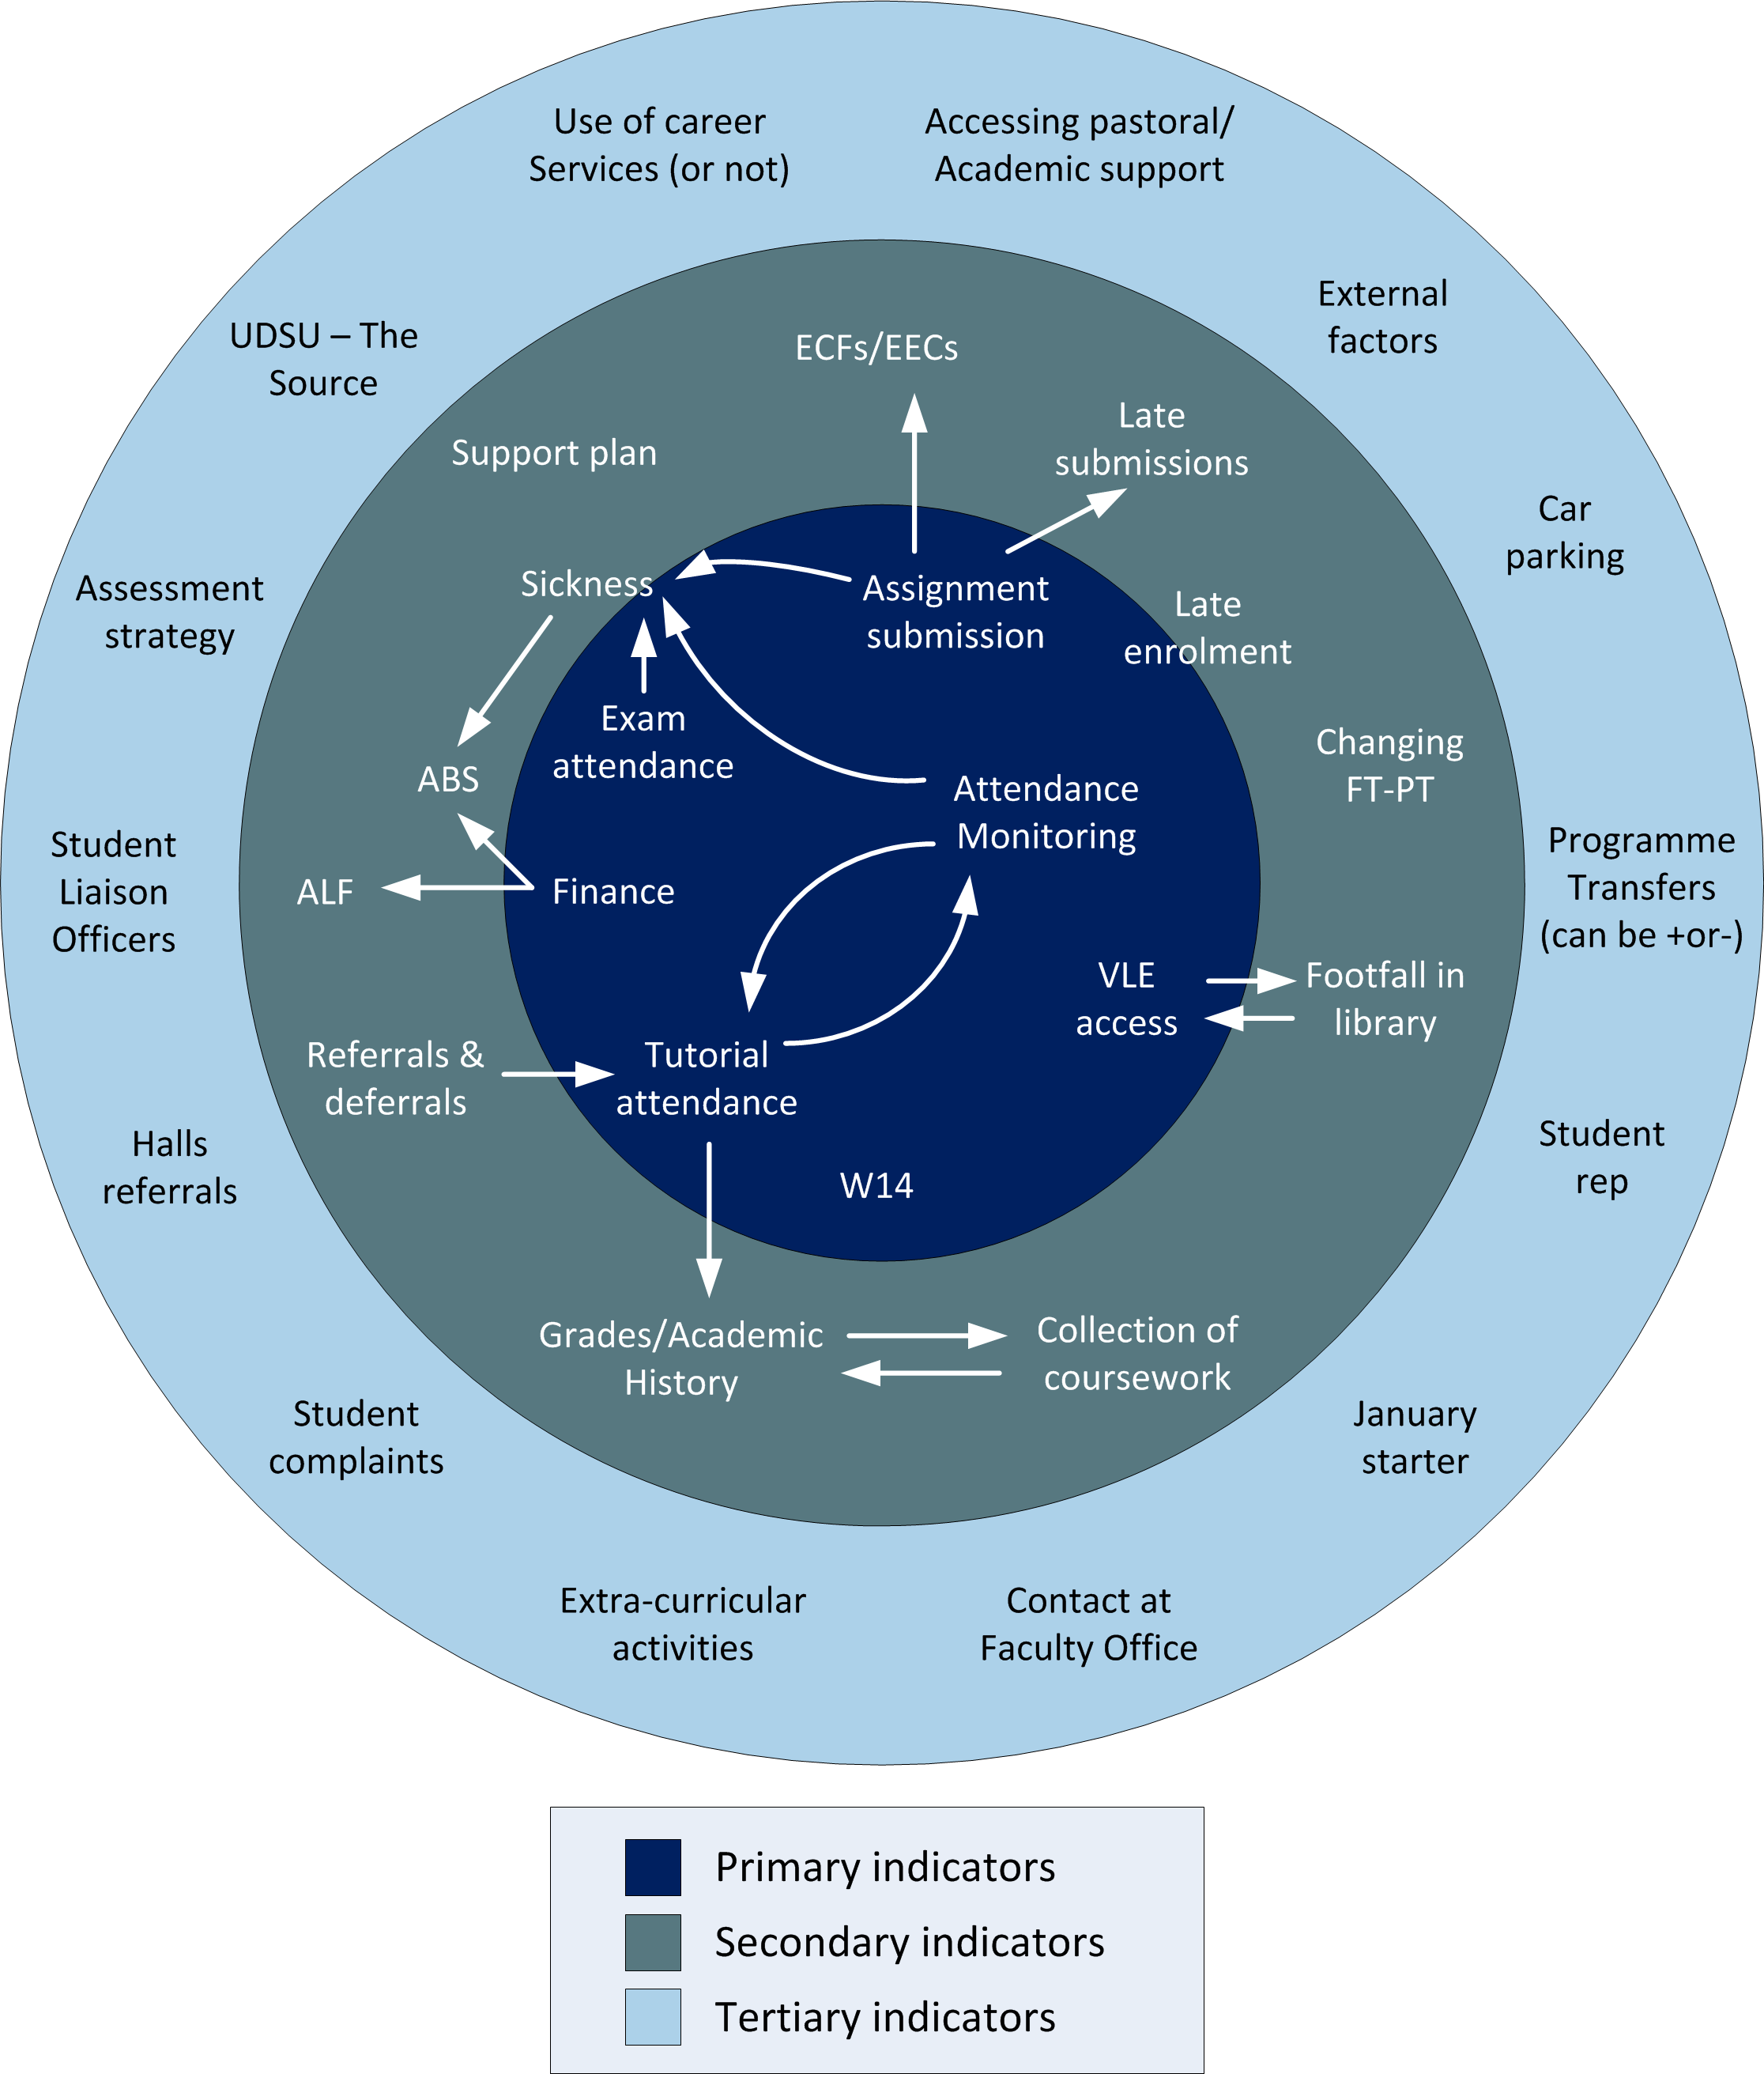
Figure 1:
These indicators can also identify students who don't have an institutional digital footprint.
Using a service design approach, technology, data and analytics were very much in the background during the workshops. The driving factor was to find out how, where and when students were (or were not) interacting with the institution.
“Derby has a very diverse student population and has been very active and successful in the widening participation agenda. We have a very high percentage of "first in family" undergraduates, and these students may not have the “social capital” of other students and so may find it hard to engage with or pick their way through our systems and processes.”

Systems and Data
From the workshops a number of systems and existing data collection/ engagement touch points were identified. It also became apparent that without too much effort existing data collection points could be tailored to capture more of the key engagement indicators. For example, the Library had done a lot of work around their footfall, but it had been designed from a library management perspective not from a student interaction perspective. However as both library staff and students were involved in the workshops it became apparent that without too much effort more student interaction data could be collected.
Engagement analytics have allowed the team to look "beyond the classroom" and help identify patterns of behavior, both academic and non-academic, that might lead to student withdrawal. This has led to insights into how the withdrawal process could be redeveloped to offer better support to “at risk” students. More information on these emerging patterns and support processes are available from the project final report.
As discussions and further work emerged from the workshops the project developed an institution wide data exploration element. It became apparent that information on students was held across over half a dozen systems that didn't actually "talk to each other" and data and operational silos were identified as an underlying issue.
The workshops have also led to a very positive ongoing relationship with the University's Statistics team. This team was already producing a range of data analysis from the student record system and other business intelligence systems; mainly for management reporting. Through wider discussions initiated by project work, there is a burgeoning relationship between the Stats team and Jean’s project team. Together they are now producing a range of data analysis based on a student engagement perspective.

Tackling the BME (black, ethinic AND MINORITY) Attainment gap
Working with the Stats team, Jean is now helping to design a range of approaches to address the BME attainment gap at Derby. Using a mix of existing assessment, biographical and demographical data they have been able to produce a range of diagrams that clearly illustrate the student success at class, module, faculty and institutional level. This is now feeding into a developing institutional wide student attainment improvement strategy.

Ethics and Data Collection
Collecting and using data has ethical and legal considerations. In the terms and conditions that students sign up for at Derby, there is a clause that states the University may use student data in ways that can support students during their student journey. So a level of appropriately anonymised student data was already available. Jean acknowledges that being based in Registry has been helpful in terms of accessing generic student data.

Communication
Communication plays a central role in any project or institutional change initiative. The language around analytics isn't commonplace to many staff and students. Jean believes taking a more holistic view, and starting with a universally understood concept such as improving the student experience has been crucial. As has been bringing people together to explore and share issues.
“It has been heartening to see people who don't usually work closely together normally and see making connections about what they do and what others do and how they could work together better.”
Discussing and contextualizing common issues can then naturally lead to discussions around data at a number of levels, from the individual to the institution.

Next steps
The SETL project set out to scope a traffic light dashboard system primarily for staff use. The institution is undergoing a major development of their student record system, and the project findings are being used to inform into its requirements gathering process. This includes the development of both staff and student facing dashboards. Ideally these would be customizable, a sort of pic and mix of data sources and representations.
As Jean and her team have delved more and more into data they are continually asking a series of questions about data such as:
- What data do we really want/need?
- What data is most meaningful
- What data can we easily get hold of?
- What can we get hold of with a little bit of work?
- What are we never going to get hold of?”
As well as thinking about developing their HEAR process to be more accessible to students and staff, Jean and her team are now starting to explore the possibilities of their new e-assignments and submissions systems and looking at ways to link that to wider student enhancement themes. There is a growing sense of excitement about the possibilities of combining more learning analytics approaches within their engagement analytics approach.

Top Tips
Jean's top tips for working with on analytics related projects:
- Keep the end user firmly in mind,
- Promote a sense of excitement and fun,
- Talk to people "the best conversations can happen in corridors",
- Work at a cross-institutional level as much as possible,
- Have access points. e.g. in-house web pages/forums where people can get involved,
- Shock people with data,
- Get people to think outside their immediate areas of focus,
- Keep an open mind as to what information your university does/could/can’t capture and how it could be used,
- Try to ensure that any data being collected can be used by as many people and systems as possible.

Further information
http://blogs.cetis.ac.uk/accessibility/2012/09/18/student-retention-engagement-analytics-at-university-of-derby/

CETIS Analytics Series
Vol.1 No.1. Analytics, What is Changing and Why does it Matter?
Vol.1 No.2. Analytics for the Whole Institution; Balancing Strategy and Tactics
Vol.1 No.3.Analytics for Learning and Teaching
Vol.1 No.4. Analytics for Understanding Research
Vol.1 No.5.What is Analytics? Definition and Essential Characteristics
Vol.1 No.6.Legal, Risk and Ethical Aspects of Analytics in Higher Education
Vol.1 No.7.A Framework of Characteristics for Analytics
Vol.1 No.8.Institutional Readiness for Analytics
Vol.1 No.9.A Brief History of Analytics
Vol.1 No.10. The Implications of Analytics for Teaching Practice in Higher Education
Vol.1 No.11.Infrastructure and Tools for Analytics
http://publications.cetis.ac.uk/c/analytics

Acknowledgements
The CETIS Analytics Series was commissioned by Myles Danson (JISC programme manager) to give an overview of current thinking around analytics in post-16 education in the UK. In addition to the authors the following people have contributed to the production of the CETIS Analytics Series; Lorna Campbell (CETIS), Adam Cooper (CETIS), Rob Englebright (JISC), Neil Jacobs (JISC), Sheila MacNeill (CETIS) and Christina Smart (CETIS). Design and Artwork by:http://www.consul4design.com

About this White Paper
Title: Case Study: Engaging with Analytics
Authors: Sheila MacNeill and Jean Mutton
Date: March 2013
URI:

Text Copyright © 2013 The University of Bolton
This work is licensed under the Creative Commons Attribution 3.0 UK Licence. For more information on the JISC CETIS publication policy see http://wiki.cetis.ac.uk/JISC_CETIS_Publication_Policy

Published by The University of Bolton

About CETIS
CETIS are globally recognised as leading experts on interoperability and technology standards in learning, education and training. We work with our clients and partners to develop policy and strategy, providing impartial and independent advice on technology and standards. CETIS are active in the development and implementation of open standards and represent our clients in national, European and global standards bodies and industry consortia, and have been instrumental in developing and promoting the adoption of technology and standards for course advertising, open education resources, assessment, and student data management, opening new markets and creating opportunities for innovation.
For more information visit our website: http://jisc.cetis.ac.uk/
This paper has been produced by CETIS for JISC: http://www.jisc.ac.uk

http://www.jisc.ac.uk/whatwedo/programmes/bce/relationshipmanagement
http://publications.cetis.ac.uk/wp-content/uploads/2011/02/Service_Design.pdf
http://jisc.cetis.ac.uk/support/relationship-management
http://www.derby.ac.uk/experience/JISC-enrolment-project
http://www.derby.ac.uk/ssis/jisc-setl
http://www.derby.ac.uk/experience/JISC-enrolment-project/blueprint-of-student-transition
http://www.derby.ac.uk/ssis/jisc-setl

