MOOCs and Open Education: Implications for Higher Education

A white paper
By Li Yuan and Stephen Powell

MOOCs and Open Education: Implications for Higher Education
Li Yuan and Stephen Powell, JISC CETIS
Table of Contents
1. Executive Summary 3
1.1. The focus of the report 3
1.2. Making sense of MOOCs 3
1.3. Analysis of MOOC initiatives 3
1.4. Issues and challenges for MOOCs 3
1.5. MOOCs as disruptive innovations 4
1.6. Implications for higher education 4
2. Introduction 5
3. Making sense of MOOCs 5
3.1. The history and key features of MOOCs 5
3.2. cMOOCs vs. xMOOCs 7
4. Analysis of MOOC-style open education initiatives 7
4.1. Key developments of MOOCS-style Initiatives 7
4.2. Motivations for MOOC providers 8
4.3. Motivations for learners 9
4.4. Business models 9
5. Issues and challenges for MOOCs 10
5.1. Sustainability 10
5.2. Pedagogy 10
5.3. Quality and completion rates 11
5.4. Assessment and credit 11
6. MOOCs: Disruptive innovation in HE? 12
6.1. Disruptive innovation theory 12
6.2. MOOCs disruption and innovation in higher education 13
7. Implications for higher education 15
7.1. Drivers and trends towards open education 15
7.2. Implications for educational policy 17
7.3. Implications for HE institutions 17
8. Conclusions 18
9. References 19

Executive Summary

The focus of the report
This report sets out to help decision makers in higher education institutions gain a better understanding of the phenomenon of Massive Online Open Courses (MOOCs) and trends towards greater openness in higher education and to think about the implications for their institutions. The phenomena of MOOCs are described, placing them in the wider context of open education, online learning and the changes that are currently taking place in higher education at a time of globalisation of education and constrained budgets. The report is written from a UK higher education perspective, but is largely informed by the developments in MOOCs from the USA and Canada. A literature review was undertaken focussing on the extensive reporting of MOOCs through scholarly blogs, press releases as well as openly available reports and research papers. This identified current debates about new course provision, the impact of changes in funding and the implications for greater openness in higher education. The theory of disruptive innovation is used to help form the questions of policy and strategy that higher education institutions need to address.

Making sense of MOOCs
MOOCs are a relatively recent online learning phenomenon, having developed from the first early examples five years ago, they are now generating considerable media attention and significant interest from higher education institutions and venture capitalists that see a business opportunity to be exploited. They can be seen as an extension of existing online learning approaches, in terms of open access to courses and scalability, they also offer an opportunity to think afresh about new business models that include elements of open education. This includes the ability to disaggregate teaching from assessment and accreditation for differential pricing and pursuit of marketing activities.

Analysis of MOOC initiatives
The opportunity that MOOCs offer for massification of courses has generated significant interest from governments, institutions and commercial organisations. A number of bespoke MOOC platforms have been developed and offer courses independent of or in collaboration with universities. A growing number of institutions have been involved in engaging and experimenting with MOOCs for the purpose of expanding access, marketing and branding, as well as the potential of developing new revenue streams. Motivations for learners to participate in MOOCs are varied, and many struggle to engage with courses and keep motivated in the context of an online learning environment. The market value of certification of courses, short of credit as part of traditional institutional awards, has yet to be determined. Other potential business models are being developed but need further work to establish them.

Issues and Challenges for MOOCs
Over recent years there has been a significant change in societal adoption of Internet technologies with extensive proliferation and use in more economically developed countries. However, in terms of the proliferation of MOOCs as an educational approach, there is a risk that the current enthusiasm is being driven by a self selecting group of highly educated, IT literate individuals who are able to navigate the sometimes complex, confusing and intimidating nature of online learning. In general, there are concerns about the pedagogy and quality of current MOOC courses, with a clear distinction between process and content-based approaches. The motivation for some MOOCs is a philanthropic one and for others a business proposition. However, in both cases, there is the challenge of finding a viable model that allows for sustainability of MOOC provision.

MOOCs as disruptive innovations
The theory of disruptive innovation (Bower and Christensen, 1995) offers an explanation as to why some innovations disrupt existing markets at the expense of incumbent players. In this case, there is a significant question for higher education institutions to address: are online teaching innovations, such as MOOCs, heralding a change in the business landscape that poses a threat to their existing models of provision of degree courses? This possibility is brought about through the combination of wider societal adoption of communication and, particularly, Internet technologies, changing funding models and the development of new business models that leverage this opportunity. If this is the case, then the theory of disruptive innovation suggests that there is a strong argument for establishing an autonomous business unit in order to make an appropriate response to these potentially disruptive innovations.

Implications for higher education
The current UK political administration has continued the course set by the government with an even more radical agenda to allow new, for-profit providers to enter the higher education market. These include, changes to funding whereby students pay most of their tuition fees, through student loans, and changes to national quality assurance measures so that new players can enter the market place and offer new, differentiated provision including more for-profit universities. There is also an opportunity here for open education where less traditional lecturing and more facilitative and guided approaches to education can find a place in this new landscape of online learning where increased fees for established models may act as a deterrent to students.

Introduction
Massive Open Online Courses (MOOCs) have recently received a great deal of attention from the media, entrepreneurial vendors, education professionals and technologically literate sections of the public. The promise of MOOCs is that they will provide free to access, cutting edge courses that could drive down the cost of university-level education and potentially disrupt the existing models of higher education (HE). This has encouraged elite universities to put their courses online by setting up open learning platforms, such as edX. New commercial start-ups such as Coursera and Udacity have also been launched in collaboration with prestigious universities, offering online courses for free or charging a small fee for certification that is not part of credit for awards. Larger corporations such as Pearson and Google are also planning to move into the HE sector as global players and are likely to adopt a MOOC-based approach as a part of their plans. A new company, Futurelearn, has been launched by the Open University in the UK, to bring together a range of free, open, online courses from leading UK universities for learners around the world (Futurelearn, 2013).
From open access to open educational resources, and more recently, open online courses, there is growing momentum among HE institutions to participate in this “open” movement. For example, the UK Open Educational Resources programmes launched in 2009, have successfully made a significant amount of new and existing teaching and learning resources freely available worldwide with copyright licenses that promote their use, reuse and re-purposing (JISC, 2012). However, although sustainability issues were a key concern of this programme, the identification of a sustainable approach for the development of OERs in institutions has proved elusive. With the backdrop of significant amounts of money invested, a criticism of OERs is that they have not yet affect traditional business models or daily teaching practices at most institutions (Kortemeyer, 2013).
The rapid expansion of MOOCs has sparked commercial interest from venture capitalists and major corporations who want to enter the HE market using a MOOC approach. Most significantly, it has opened up strategic discussions about the disruptive potential of MOOCs in HE and forced established providers to re-visit online learning and open education as strategic choices for the future. Given the context just described, higher education institutions (HEI) will need to make informed decisions about how to serve their specific mission and how to respond to the different needs of learners in a rapidly changing educational market. The speed of development opens up the risk that decisions will be made in a fragmentary way by different unconnected groups without a deep understanding or clear analysis of MOOCs and other potential education delivery models. Institutions will need to develop a cohesive strategy to respond to the opportunities and threats posed by MOOCs and other forms of openness in HE.
In order to raise awareness of MOOCs and their implications for HE, this report synthesises the latest thinking and on-going debates on MOOCs from the media, including blogs and press releases, and from material published by individuals and organisations. This report intends to help decision makers in HEI gain a better understanding of the phenomenon of MOOCs and their potential as a disruptive innovation as a part of the trend towards greater openness in HE.

Making sense of MOOCs

The history and key features of MOOCs
Following on from the development of Open Education Resources and the Open Education movement (Yuan, et al., 2008), the term Massive Open Online Courses (MOOCs) was first introduced in 2008 by Dave Cormier to describe Siemens and Downes’ “Connectivism and Connective Knowledge” course. This online course was initially designed for a group of twenty-five enrolled, fee paying students to study for credit and at the same time was opened up to registered only learners worldwide. As a result, over 2,300 people participated in the course without paying fees or gaining credit (Wikipedia, 2012). In 2011, Sebastian Thrun and his colleagues at Stanford opened access to the course they were teaching at the university, “Introduction to Artificial Intelligence”, and attracted 160,000 learners in more than 190 countries (Wikipedia, 2012). Since then, MOOCs have become a label for many recent online course initiatives from institutions, individuals and commercial organisations.
The original aim of MOOCs was to open up education and provide free access to university level education for as many students as possible. In contrast to traditional university online courses, MOOCs have two key features (Wikipedia, 2012):
- Open access - anyone can participate in an online course for free
- Scalability - courses are designed to support an indefinite number of participants
However, these features may be interpreted differently by different MOOC providers; some MOOCs are massive but not open and some are open but not massive. Wiley (2012) pointed out that the ambiguities in the concept of MOOCs may pose a threat to the future development of open educational resources and open courses where the general public will perceive ‘free’ is good enough and no one will care about ‘open’. This raises questions about the licensing and permissions of current MOOC provision and how it relates to the creative commons licenses promoted by the OER community.
The development of MOOCs is rooted within the ideals of openness in education, that knowledge should be shared freely, and the desire to learn should be met without demographic, economic, and geographical constraints. As figure 1 shows, since 2000 the concept of openness in education has been evolving rapidly, although it has its origins in the early 20th century (Peters, 2008). Massachusetts Institute of Technology (MIT) established OpenCourseWare in 2002 and the Open University set up OpenLearn in 2006, representing an ongoing development of the open education movement. Influenced by the early development of MOOCs, various open learning platforms have been set up by elite institutions; examples from 2012 include MIT edX and OU’s Futurelearn. A key message that emerges is that the evolution of MOOCs is leading to more players in the market as HEI and private organisations seek to take advantage of these innovations in online learning.
Figure 1: MOOCs and Open Education Timeline
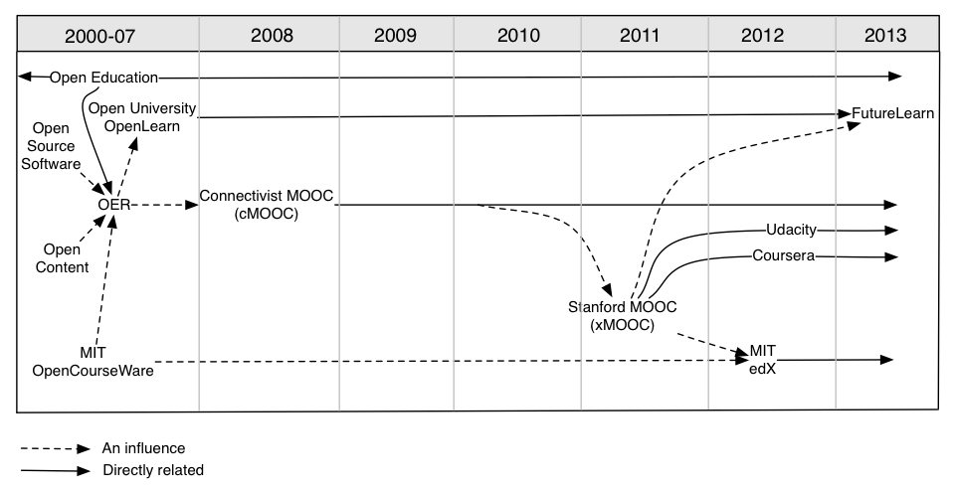

cMOOCs vs. xMOOCs
Different ideologies have driven MOOCs in two distinct pedagogical directions: the connectivist MOOCs (cMOOC) which are based on a connectivism theory of learning with networks developed informally; and content-based MOOCs (xMOOCs), which follow a more behaviourist approach. In many ways, this is the same learning process versus learning content debate that educationalists have had for many decades and failed to resolve.
cMOOCs emphasise connected, collaborative learning and the courses are built around a group of like-minded ‘individuals’ who are relatively free from institutional constraints. cMOOCs provide a platform to explore new pedagogies beyond traditional classroom settings and, as such, tend to exist on the radical fringe of HE. On the other hand, the instructional model (xMOOCs) is essentially an extension of the pedagogical models practised within the institutions themselves, which is arguably dominated by the “drill and grill” instructional methods with video presentations, short quizzes and testing.
A further division of xMOOCs into two models can be identified: profit and non-profit to serve different purposes. xMOOCs cane be seen as part of MITs continued development of their Open Courseware initiative offering the opportunity to learners from different parts of the world to access high quality teaching and learning for free. However, the opportunity for branding and marketing for institutions is also recognised and seen to be valuable. In addition, venture capitalists are interested in the financial capital that can be generated by xMOOCs and have set up commercial companies to help universities to offer xMOOCs for profit, e.g. Coursera and Udacity.

Analysis of MOOC-style open education initiatives
The following section analyses recent initiatives that have been launched to make teaching, learning resources, and courses in various subjects and levels, available online.

Key developments of MOOCS-style Initiatives
edX (https://www.edX.org/) is a non-profit MOOCs platform founded by Massachusetts Institute of Technology and Harvard University with $60 million of resources contributed by the two institutions to support the project. Currently, there is a total of eight courses including chemistry, computer science, electronics and public health, but it is anticipated that there will be between 20 to 30 courses in 2013. MITx and Harvardx courses will not be offered for credit at either university but online learners who demonstrate mastery of subjects can pay a modest fee for a certificate of completion.
Coursera (https://www.coursera.org/) is a for-profit company, which started with $22 million total investment from venture capitalists, including New Enterprise Associates and Kleiner, Perkins, Caufield & Byers Education. There are four university partners, namely Stanford University, Princeton University and the Universities of Michigan and Pennsylvania. Coursera currently has 197 courses in 18 subjects, including computer science, mathematics, business, humanities, social science, medicine, engineering and education. Some partner universities offer credit for their Coursera classes to those who want to pay a fee to have some extra assignments and work with an instructor and be assessed.
UDACITY (https://www.udacity.com/) is another for-profit start-up founded by Sebastian Thrun, David Stavens and Mike Sokolsky with $21.1 million investment from venture capitalist firms, including Charles River Ventures and Andreessen Horowitz. Udacity currently offers 18 online courses in computer science, mathematics, general sciences, programming and entrepreneurship. When students complete a course, they receive a certificate of completion indicating their level of achievement, signed by the instructors, at no cost. Some universities began offering transfer credit for Udacity students who then take the final examination at a Pearson centre.
Udemy (https://www.udemy.com/) founded in 2010, with a total $16 million investment from Insight Venture Partners, Lightbank, MHS Capital, 500 start-ups and other investors provides a learning platform, which allows anyone to teach and participate in online video classes. Udemy currently offers over 5,000 courses, 1,500 of which require payment, with the average price for classes falling between $20 and $200.
P2Pu (https://p2pu.org/en/) was launched in 2009 with funding from the Hewlett Foundation and the Shuttleworth Foundation. P2PU offers some of the features of MOOCs, but is focused on a community centred approach to provide opportunities for anyone that is willing to teach and learn online. There are over 50 courses available and the process of improving the quality of the courses relies on community-review, feedback and revision. There are no fees or credits, but P2PU's school of Webcraft adopted a badge reward system to integrate elements of gamification into the learning process.
Khan Academy (https://www.khanacademy.org/), another well-known free online learning platform, is a not-for-profit educational organisation with significant backing from the Bill & Melinda Gates Foundation and Google. The Khan Academy, started by Salman Khan in 2008, offers over 3,600 video lectures in academic subjects with automated exercises and continuous assessment.
Whereas edX offer only Harvard and MIT’s courses, Coursera focuses on providing a platform that any university can use and Udacity only offers its own curriculum with specialised areas. Other open education initiatives, such as Udemy, P2PU and Khan Academy have been around for a while and provide opportunities for anyone to learn with experts, peers and others outside traditional universities. Table 1 indicates the major differences between the initiatives described above in terms of financial motivation, access, fees and credits.
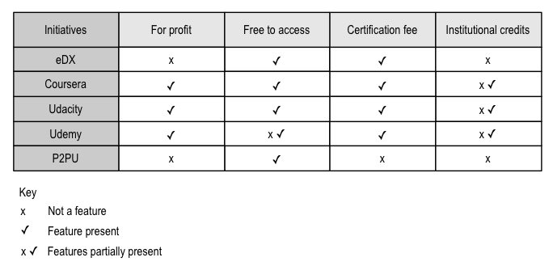
Table 1: Comparison of key aspects of MOOCs or Open Education initiatives

Motivations for mooc Providers
The scale and open nature of MOOCs provides opportunities for expanding access to HE to all and creates a space for experimentation with online teaching and learning. This exploration of new approaches for HE provision has generated significant interest from governments, institutions and commercial organisations. The current value propositions for institutions to engage with MOOCs are identified as “education access, experimentation and brand extension” (Educause, 2012). MOOCs can expand access to education, for those who are interested and extend institutions’ reach and reputation internationally. The ‘digital footprint’ of learners using the technology is captured in large data sets that can, potentially, provide useful insights into online teaching and learning with very large numbers of students at low or minimal cost. For example, edX institutions such as MIT and Harvard use MOOCs to understand “how students learn” and “improve innovations in teaching and learning on campus”.
Advocates see MOOCs as a disruptive innovation that will transform higher education (Shirky, 2012). To them, MOOCs provide a powerful tool to make fundamental changes in the organisation and delivery of HE over the next decade. For politicians, MOOCS help address the problem of HE budget constraints and help to lower the cost of degree courses by enabling inexpensive, low-risk experiments in different forms of HE provision (Carey, 2013). Commercial organisations see MOOCs as a way to enter the HE market by providing a MOOC platform and developing partnerships with existing institutions and to explore new delivery models in HE. For example, Udacity has teamed up with Google, NVIDIA, Microsoft, Autodesk, Cadence and Wolfram to develop new courses, including HTML5 game development and mobile applications development. For those organisations, MOOCs have a viable role in selection and recruitment of talented employees.

Motivations for Learners
Learners’ motivation to participate in MOOCs is a significant area of interest to many HE stakeholders. There are many factors that influence students’ motivation to learn; these include future economic benefit, development of personal and professional identity, challenge and achievement, enjoyment and fun. What motivates the MOOC learner? Surveys conducted by researchers at Duke University show that student motivations typically fell into one of four categories (Belanger and Thornton, 2013):
- To support lifelong learning or gain an understanding of the subject matter, with no particular expectations for completion or achievement,
- For fun, entertainment, social experience and intellectual stimulation,
- Convenience, often in conjunction with barriers to traditional education options,
- To experience or explore online education.
On the pre-course survey, fun and enjoyment were selected as important reasons for enrolling by a large majority of students (95%) and on the post-course survey, most reported that they have a general interest in the topic (87%). Students used the online course to help them decide if they want to take college/university classes (15%) while a significant minority of students claimed that they could not afford to pursue a formal education (10%). Further research will be needed in order to understand learner motivations at the outset, and also what maintains learner motivation during a MOOC course.

Business Models
The most common revenue stream for the major new MOOC providers is to charge fees for certificates. Whilst edX is a not-for-profit MOOC platform with the goal of helping universities achieve shared educational missions, in the longer term it will also need to be self-sustaining. Coursera and UDACITY are examples of for-profit organisations, they are working on developing a variety of business models, and according to their published commercial strategies, these include: selling student information to potential employers or advertisers; fee-based assignment grading; access to the social networks and discussions; advertising for sponsored courses; and tuition fees for credited courses (Educause, 2012). Table 2 provides an overview of potential business models proposed by current MOOC providers.

edX | Coursera | UDACITY
- Certification | - Certification  - Secure assessments  - Employee recruitment  - Applicant screening  - Human tutoring or assignment marking  - Enterprises pay to run their own training courses  - Sponsorships  - Tuition fees | - Certification  - Employers pay for recruit talent student  - Students résumés and job match services  - Sponsored high-tech skills courses
Table 2: Overview of potential business models

Issues and challenges for MOOCs
The attention verging on hyperbole around MOOCs has raised many concerns and criticisms in educational fora. This section investigates issues relating to sustainability (business models), pedagogical issues, quality and completion rates, and the awarding of HE credit for MOOCs.

Sustainability
According to Global Industry Analysts (2010), the global e-learning market will reach $107 billion by 2015. However, it is not entirely clear how the MOOC approach to online education will make money. Most MOOC start-ups do not appear to have clear business models and are following the common approach of Silicon Valley start-ups by building fast and worrying about revenue streams later.
Some common approaches to generate revenue are considered by Coursera and other start-ups working in partnership with HEI, including: charging students a fee for certificates of participation, completion or even transcripts; providing premium services such as recruiting tools that link employers with students who have shown ability in a given area; and philanthropic donations from individuals and companies. However, it is a significant challenge for partner universities to generate income in these ways. In established business models, universities have control of the customer value proposition in that they provide any recognition of learning and set tuition fees. For MOOCs, most participating institutions have decided that they will not offer credits as part of traditional awards for these courses, probably as a result of concerns about the quality of the courses and the downside risks posed to their branding. It would be also against the initial ideals of MOOCs if universities started to charge tuition fees for their courses. Therefore, many institutions participating in MOOCs consider the courses they offer to be a branding and marketing activity at present.

Pedagogy
There are two concerns regarding pedagogy for MOOCs:
- Do MOOCs follow a sound pedagogy and organisational approach to online learning that will lead to quality outcomes and experiences for students? And,
- What new pedagogies and organisational mechanisms might be required if MOOC are to deliver a high quality learning experience?
xMOOCs have been criticised for adopting a knowledge transmission model; in essence, they are considered to be technology-enriched traditional teacher-centred instruction (Larry, 2012). Such systems offer an individualised experience in that they allow students to take alternative routes through material and offer automated feedback. However, they do not provide a social learning experience or one of being dealt with personally. Coursera leaves the design of the courses up to the individual institutions within broad guidelines. However, it is likely that few institutions have enough staff with significant working knowledge of online pedagogy involved in the development of these courses.
By contrast, cMOOCs provide great opportunities for non-traditional forms of teaching approaches and learner-centred pedagogy where students learn from one another. Online communities ‘crowd-source’ answers to problems, creating networks that distribute learning in ways that seldom occur in traditional classrooms in universities. For example, institutions, like MIT and Edinburgh University are using MOOCs as an experimental venture to participate in emerging pedagogical models, exploiting peer support and using peer assessment techniques.

Quality and completion rates
The issue of quality assurance of MOOCs is a big concern for HEIs. In most cases, compared to other online courses, MOOCs lack structure, and rarely include the central role of the instructor or teacher. They are largely self-directed learning, which is a very different experience to formal education. The open nature of MOOCs creates a population that is self-selected to be engaged and passionate about this approach to learning. MOOCs demand a certain level of digital literacy from the participants, which has raised concerns on inclusivity and equality of access.
Typically, there tends to be little formal quality assurance for MOOCs. It has been suggested that one approach could be for them to be evaluated by learners and educators, leading to league tables that rank the courses by the quality of the offering (Daniel, 2012). In this way, it is possible that courses from institutions and individuals that rate poorly will either disappear due to lack of demand or will survive by improving course quality in response to poor ratings. Arguably, for MOOCs, the most significant form of quality assurance and enhancement comes from the reflections and informal evaluations of the enthusiasts who put on the courses and comments from participants using social media.
Whether the dropout rates and progression should be a concern for MOOCs is a contested debate. Meyer (2012) reported that the dropout rates of MOOCs offered by Stanford, MIT and UC Berkley were 80-95%. For example, only 7% of the 50,000 students who took the Coursera-UC Berkeley course in Software Engineering completed. There is a similar reported dropout rate in Coursera’s Social Network Analysis class where only 2% of participants earned a basic certificate and 0.17% earned the higher level programming with distinction certificate. Whether or not these rates matter depends largely on the perceived purpose of the MOOCs in the first place. If the aim is to give the opportunity of access to free and high-quality courses from elite universities and professors, then high dropout rates may not be a primary concern (Gee, 2012). However, it is widely agreed that it would be useful to improve the retention rates of MOOCs by finding out why and at what stage students drop out of courses.

Assessment and Credit
Most MOOCs use quizzes as their main instrument of assessment – short multiple choice questions with automated answers for feedback. Some may offer other types of assessment that require open responses, but with limited resources it is not possible for thousands of essay assignments to be marked by one lecturer. Some MOOCs rely heavily on peer engagement and assessment to support the individual student's learning process. Coursera, for example, includes submission of essay style answers, graded through peer assessment, to balance the scale with the available resource. Some concerns are expressed around cheating and plagiarism with online learning, particularly where courses are eligible for academic credits. On the one hand, MOOCs' scale may magnify the issue; on the other hand, the majority of MOOCs do not offer academic credits so there may be fewer concerns in this respect. Measures taken by MOOCs to avoid the issue include Coursera teaming up with Pearson test centres to provide in person examinations.
MOOCs often give participants opportunities to earn badges or a certificate of completion. In some cases, they may even be able to gain credits towards a degree qualification. However, it has been observed that most learners using MOOCs are people who already have a degree. In this case, whether the course carries credit seems less important compared to whether they have evidence through certification that they have participated in a programme of learning and that they can present to an employers as evidence of professional development.

MOOCs: Disruptive innovation in HE?
This section will use disruptive innovation theory (Bower and Christensen, 1995) to examine MOOCs development and how their approach could be used to help institutions explore innovative approaches for teaching and learning and to develop new business models in order to gain competitive advantages in the education market.

Disruptive innovation theory
In the context of technology and business literature, the term “disruptive innovations” denotes innovations that deliver a physical product or a service to consumers in such a way as to go against market expectations. Christensen (2003) identified two types of innovations that affect organisations and businesses; sustaining and disruptive. According to Christensen, a sustaining innovation is about improving the existing system while a disruptive innovation creates an entirely new market, typically by lowering price or designing for a different set of consumers or different needs of existing customers. Typically disruptive innovations combine a new technology that has the potential to evolve rapidly, with an innovative business model. Figure 2 presents a model of disruptive innovation that illustrates the current development of MOOCs.
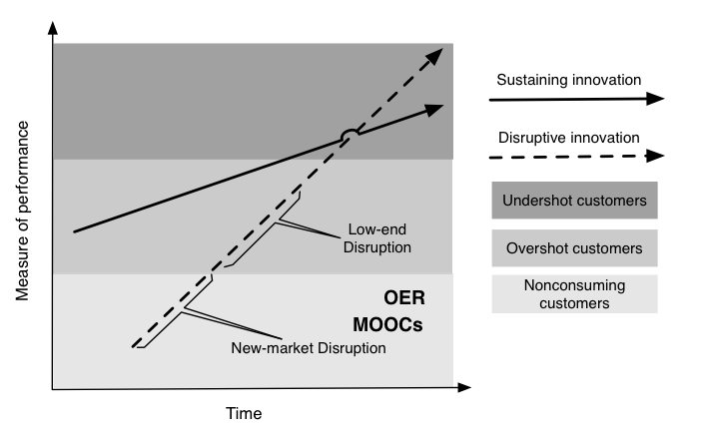Figure 2. Sustaining innovation, disruptive innovation and MOOCs
In general, sustaining innovations target demanding, high-end customers who demand better performance of an existing product or service and they are prepared to pay more for it – ‘undershot customers’. Disruptive innovations, by contrast, do not attempt to bring better products to established customers. They are innovations that develop a new-market disruption or take root at the low-end of an existing market offering a low-end disruption with a performance that is less than currently available products, but at a cheaper price to customers who find this attractive. Over time, their performance improves and they move up-market, eventually competing with established market leaders. Christensen (2003) pointed out that established market leaders are often extremely good at exploiting sustaining innovations in order to achieve the short-term company growth but it is new companies that emerge to exploit disruptive innovations. The theory of disruptive innovation suggests that it is necessary to set up an autonomous unit in order to escape the host organisation's current culture, processes, systems and decision making from blocking an appropriate response to a potentially disruptive innovation, until it is too late. For HEIs, the key question is how to identify and respond to disruptive innovations, in this particular case, MOOCs.

MOOCs disruption and innovation in higher education
MOOCs promise to offer flexibility, affordable access and fast-track completion at a low cost for whoever is interested in learning. As figure 2 shows, a disruptive innovation analysis of MOOCs identifies the initial market segment as being non-consuming costumers of HE for whom a new product is created by converting complicated, expensive HE provision into simpler, more affordable ones. Typically this is achieved by offering free courses to a different set of learners or meeting different needs of existing students in HE institutions. The analysis shows that MOOCs contain key characteristics of disruptive innovation, i.e., a combination of new business models with an enabling technology.
Disruptive innovations have reshaped markets and shifted the power from the established players to new start-ups and alternative providers in the global technology, social media and music industries. A key question for HEIs is: will MOOCs replicate the pattern of disruption seen in other market places?
At this early stage of MOOCs adoption, it is difficult to predict the impact of the new start-ups described in 6.1 on conventional HE providers. It is also worth noting that education is a complex system, which involves multiple players, complicated processes, and in some cases highly regulated markets with significant state subsidy and incentive to study with established institutions. Therefore, using disruptive innovation to explain the phenomenon of MOOCs in HE should be applied with caution to avoid superficial conclusions. Furthermore, current HE provision is in a different marketplace setting compared to technology, media and news, etc. For example Zhu (2012) compared MOOCs with how digital format, the Internet and later iTunes disrupted the music industry. He pointed out that the new alternatives replaced traditional CD-based music distribution by promising lower cost and more convenience. However, in HE, there is not so much overlap between universities’ existing markets, which serve qualified young students, and the new start-ups’ market, which focuses on professionals or people who cannot afford or gain places to traditional universities. Therefore, MOOCs cannot replace existing universities in the same way as iTunes replaced CDs in the music industry. However, the combination of technology enablers and new business models opens up the possibility that MOOCs can extend a low-cost new-market disruption to students demanding better performance. If MOOCs can be developed to the point whereby learners can complete full degrees and gain qualifications it may impact on enrolment at traditional institutions and contribute to a reshaping of the HE market in the future.
As Clayton Christensen pointed out, all technologies can be applied to sustain or disrupt any industry’s incumbents (Christensen, 2003). New start-ups, such as Coursera and Udacity have adopted MOOCs as disruptive innovations with a focus on developing new business models, new markets and new ways to serve different needs of learners. In contrast, most HE institutions see MOOC development as a sustaining innovation to improve their performance through experiments with new forms of online learning. For example, edX institutions such as MIT and Harvard are using MOOCs as an experimental space to learn how to educate their on-campus students more effectively (Bates, 2013). San Jose State University are trying out MOOCs in traditional classes, "flipping" the experience so students take the MOOCs as homework and engage in deep problem solving in the classroom (Jarrett. 2012).
In the last decades, various distance and open learning programmes and online educational delivery models have been developed to address access, affordability, and personalised learning in HE (Hill, 2012). In the UK, the HE sector has increasingly attempted to use technology to make university courses more accessible and flexible in order to reach more students nationally and internationally (White, et al., 2010). No doubt the rapid development of MOOCs has captured the imagination of policy makers, investors and educators and persuaded them to fund various MOOCs platforms and open online learning programmes.
The lessons learnt from the early online learning initiatives in the UK are worth considering for developing future MOOC initiatives in HE. For example, the UKeU programme invested £50 million in 2003 to develop an online learning platform for delivering UK universities’ online courses internationally but only succeeded in attracting 900 students. One of the main reasons for its failure was considered to be the fact that the approach took a supply-driven rather than demand-led approach. Some key findings from a report produced by the House of Commons Education and Skills Committee (2005) suggest that thorough market research, sound business plans and appropriate pedagogical approaches are keys in order to design and deliver online learning programmes more effectively to meet learners needs. The UK Open University founded in 1969, has successfully offered low cost and flexible study opportunities to overcome barriers to education for people who were not able to attend a ‘proper’ university. Their experiences indicate that a much greater up-front investment of resources, time and careful planning is needed when designing distance-learning courses (Casey, 2012). This is also evidenced by the newly released report for Duke University’s first MOOC on Bioelectricity, which shows that over 600 hours of effort were required to build and deliver the course, including more than 420 hours of effort by the instructor (Belanger & Thornton, 2013).

Implications for Higher education

Drivers and trends towards open education
The emergence of MOOC style innovations shows a convergence of interests in social, economic and technology developments in education in a global context. There is the potential for open education to play an important role in ensuring access to education for all and addressing the issues and challenges of an ever-changing environment that needs new ways to deliver and access to HE in the future, these changes include:
- Globalisation and the increased momentum for internationalisation in higher education
- Worldwide growth and increasing demand for access to higher education, with the projection that there will be 120 million students worldwide by 2020.
- Changing learner demographics, experience and demands of the dramatically increasing numbers of lifelong adult learners
- Highly increased access to personal technology and social media
- The need for changes in cost, affordability and economic models for higher education
Therefore, there is a clear need for new business models and innovations in higher education to meet the challenges of social and economic changes in the longer term. For example, the EU funded TEL-Map project (TEL-Map, 2012) has developed four scenarios for future higher education in the UK, namely the Unidiversity model, Traditional University model, Hybrid University model and Online University model, see figure 3.

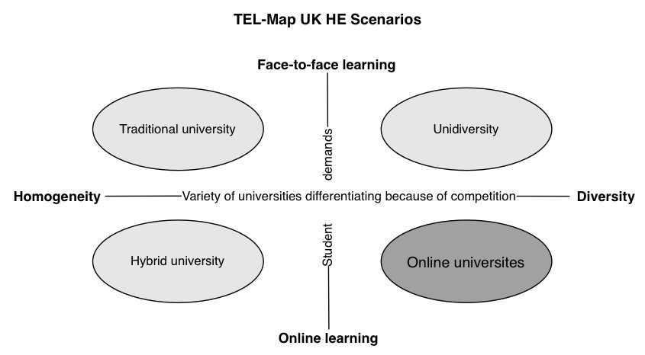
Figure 3. Four Scenarios of Future Higher Education
The Online University scenario represents a future of openness in higher education. In this scenario, competition between universities, with increasingly differentiated and innovative use of technologies, creates a wide variety of open education provision. In this model, students undertake largely independent study with free courses, and paid-for external examinations for degrees awarded when they feel ready to take them.
Within the movement towards open education, this new paradigm opens up opportunities for sharing ideas, collaborating between institutions, educators and learners locally and internationally, and for facilitating more meaningful engagement in teaching and learning. A number of related aspects of openness are emerging in different areas, such as those illustrated in Figure 4.
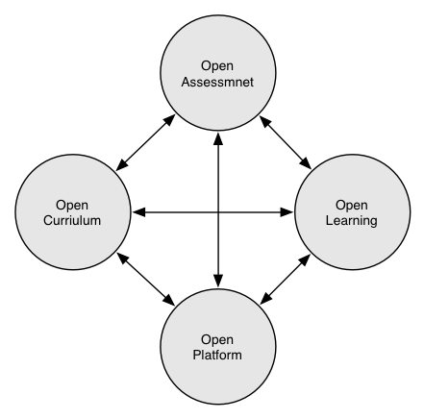
Figure 4: Opening Up Higher Education
Open Curriculum: learners mix educational resources, activities, and/or packages for different disciplines to meet their needs. This places learners in charge of their own learning and ensures that they will learn what they need to meet their personal desires and requirements.
Open Learning: instructors, experts and/or peers will, through various activities, generate and share new ideas and new understanding during the learning process. This provides learners with opportunities for self-determined, independent and interest-guided learning.
Open Assessment: instead of the “monopoly” on formal evaluation of learning results, previously led by accredited education providers, assessment of what learners have learned is carried out by their instructors, others and peers during the learning process via peer to peer or crowd-sourced assessment with “on-demand accreditation” for learners.
Open Platform: supports a dynamic and interactive open education community by creating and maintaining an engaging, intuitive and stable user interface for educators and learners. Cloud–based provision and the use of open standards makes it easier for different platforms and services to exchange information and data.
Open education brings new opportunities for innovation in HE that will not only support institutions to implement the fundamental values of university based education but it will also shift the focus from traditional lecturing to more learner-centred learning in higher education.

Implications for educational policy
Higher education is already experiencing a period of unprecedented change worldwide. The cost of funding HE has become a focus of national policy with most governments looking for new funding mechanisms, reduced costs and improvements in the quality of teaching and learning. There is significant momentum behind the concept of free and open access to high quality university learning, and it is likely that content and courses will continue to be promoted resulting in more MOOCs and other types of open education approaches emerging. However, there is also a need to rethink current higher education structures and policies that obstruct innovation. Three key areas have become the policy concerns and debates in response to current developments in MOOCs and open education in HE: funding for higher education institutions; degree provision; and quality assurance.
The existing HE funding model has been considered to be a major barrier to exploring new business models and innovative approaches in institutions (Christensen, 2003). In the UK, the Minister for Universities and Science, David Willets has expressed his concerns about the existing British HE funding model and in response has begun to move English HEIs towards an open market economy where student fees will provide the primary source of teaching income rather than government grants (Willets, 2011). This push to develop more choice comes at an increased financial cost to the learner and, despite the provision of state-backed loans, how this will be reflected in the demographics of students who access HE in the future is unknown. The increasingly competitive climate will put significant pressure on traditional universities to find new ways of teaching students to reduce costs to give flexibility with fees. Existing universities might, for example, set up commercial subsidiaries to provide more open and flexible provision; the Open University’s Futurelearn is one example of a new, more flexible organisation.
The ability to award a recognised degree has become a bottleneck for private providers to fully participate in the HE market. There is a great debate on whether certification should or could be disaggregated from teaching and if so what does it mean to study at higher level? Following the announcement that Pearson in the UK will create a new degree-level BTEC, David Willetts urged that there is a need to make it easier for teaching universities to use other institutions’ degrees and to encourage cooperation between private providers and universities. For example, he suggested that it should be possible to offer Open University degrees through further education colleges or other new alternative providers (Willetts, 2011). However, there are concerns that allowing for more diverse degree provision amongst providers will threaten the accountability of higher education institutions and put quality at risk.
The British government has identified the priority to remove various barriers that obstruct innovation in higher education and support different approaches and models for delivering course and degrees in institutions, although whether the consequences of their actions are will enable or constrain innovation is arguable. A contrasting approach is taken in Scotland, where continuing high levels of direct government support for HE are a priority to ensure widespread access regardless of financial means. The big challenge for education policy is how to support openness as a core value in higher education while creating choice for learners in HE provision from traditional universities and new entrants.

Implications for HE institutions
The emergence of new educational delivery models including the rapid development of MOOCs is another source pressure on conventional HE institutions, but also offers opportunities for those institutions able to change and develop new provision. Foremost this requires institutions to address strategic questions about online learning and where the different innovations such as MOOCs fit within their activities. It is a mistake to see MOOCs as an isolated issue on which policy and strategic decisions need to be taken, as they are part of a broader landscape of changes in HE that includes the development of open education. It can be argued that MOOCs have the potential to impact on higher education in two ways: improving teaching; and encouraging institutions to develop distinctive missions that will include considerations about openness and access for different groups of students. MOOCs also provide institutions with a vehicle to think creatively and innovatively and to explore new pedagogical practices, business models and flexible learning paths in their provision.
Increasingly, openness will play an important role in driving educational innovation and transforming higher education. A large number of organisations, governments, institutions, educators and learners around worlds have participated in the OER movement by funding, supporting, producing and accessing educational resources online freely. While producing, sharing and reusing OERs are being explored among academics, open courses, including MOOCs will potentially also open up the teaching process. This will provide opportunities for educators to share and participate in courses run by follow educators from different institutions and countries to explore advantages and disadvantages of different pedagogical approaches in various learning contexts and enrich learners’ experience through the participation of other experts in their courses.
New business strategies and models will be needed in response to the challenges posed by new funding structures and tuition fees and the new contexts that HEI operate in. The potential of MOOCs to open up higher education to the masses has challenged the traditional way of thinking about delivering higher education. Many HEI will be forced to explore new business models that will deliver online education at lower costs and expand the range of their provision both for strategic reasons and in response to demand from learners. Disruptive innovation and associated theories may offer HE institutions some possible business solutions and strategies to respond to the evolution of MOOCs, for example, setting up new units with different resources, processes, and priorities to explore new educational approaches and services. Institutions can launch new market disruptions to target those who are not able to go to universities, or they may launch up-market sustaining innovations by reducing the cost and providing better learning experiences without extra cost or low end market disruptions to target those who look for simple and straight forward courses rather than complicated university degrees. Institutions will need to assess their strengths and develop a strategic plan that enables them to make the most of campus and online education by providing MOOCs or other open education initiatives.
With the popularity of MOOCs, universities and colleges will need to rethink how to make their curriculum delivery models and courses truly flexible and accessible. Many HEI have sought to make learning more flexible with course modular design and bankable credits to encourage learners to study at a time and peace that suits their own needs. Open courses based on new structures, ways or working and use of technology can make higher education more cost effective and accessible and may also contribute to balancing work, family and social life. Learners have access to a variety of non-traditional learning models including access to courses and materials to self-direct their own learning beyond their classes and institutions. More flexible models and open approaches will encourage more mature students to participate in higher education and gain qualifications to further their careers.

Conclusions
MOOCs promise to open up higher education by providing accessible, flexible, affordable and fast-track completion of universities courses for free or at a low cost for learners who are interested in learning. The popularity of MOOCs has attracted a great deal of attention from HE institutions and private investors around the world seeking to build their brands and to enter the education market. Institutions will need to look more closely at and learn from the different initiatives outside traditional institutions that are developing new business, financial and revenue models to meet the different needs of new groups of learners in an open HE marketplace. Open education brings new opportunities for innovation in higher education that will allow institutions and academics to explore new online learning models and innovative practices in teaching and learning. At a national and international level, new frameworks for HE funding structures, quality insurance and accreditation to support different approaches and models for delivering higher education will be required. Policy makers will need to embrace openness and make education more affordable and accessible for all and at the same time be profitable for the institutions in an open higher education ecosystem.

References
Bates, T. (2013) Harvard’s current thinking on MOOCs, http://tinyurl.com/a2uh86z
BBC, (2012), UK university applications down as fees rise, http://www.bbc.co.uk/news/education-16787948
Belanger, V., Thornton, J. (2013), Bioelectricity: A Quantitative Approach - Duke University’s First MOOC
Bower, J., Christensen, C., (1995). Disruptive technologies: catching the wave. Harvard Business Review, pp.41–53. https://cbred.uwf.edu/sahls/medicalinformatics/docfiles/Disruptive Technologies.pdf
Carey, K., (2013), Obama, Rubio Agree on One Thing: Technology Could Fix the Higher Ed Mess, http://tinyurl.com/cogw2kh
Casey, J. (2012), Taking Care of Business? The political economy of MOOCs and Open Education, http://tinyurl.com/ao2agyc
Christensen, C., Johnson, C.,W, Horn, M.,B (2008), Disrupting Class: How Disruptive Innovation Will Change the Way the World Learns, http://tinyurl.com/apnfhls
Christensen, C., M. (2003). The innovator's solution: creating and sustaining successful growth. Harvard Business Press.
Daniel, J. (2012), Making Sense of MOOCs: Musings in a Maze of Myth, Paradox and Possibility, http://tinyurl.com/ak8qvdv
Educause, (2012), What Campus Leaders Need to Know About MOOCs, http://tinyurl.com/c7gqj65
Futurelearn (2013), Futurelearn launches, http://futurelearn.com/feature/futurelearn-launches/
Jarrett, J (2012), What Are 'MOOC's and Why Are Education Leaders Interested in Them?, http://www.huffingtonpost.com/impatient-optimists/what-are-moocs-and-why-ar_b_2123399.html
JISC, (2013), Open educational resources programme, http://www.jisc.ac.uk/whatwedo/programmes/elearning/oer.aspx
Gee, S. (2012), MITx - the Fallout Rate, http://www.i-programmer.info/news/150-training-a-education/4372-mitx-the-fallout-rate.html
Global Industry Analysts, (2010), ELearning: A Global Strategic Business Report , http://www.strategyr.com/eLEARNING_Market_Report.asp
Larry, C. (2012) MOOCs and Pedagogy: Teacher-Centered, Student-Centered, and Hybrids (Part 1) http://larrycuban.wordpress.com/2013/02/13/moocs-and-pedagogy-part-2/
Hill, P (2012), Online Educational Delivery Models: A Descriptive View, http://www.educause.edu/ero/article/online-educational-delivery-models-descriptive-view
Meyer, R. (2012). What it’s like to teach a MOOC (and what the heck’s a MOOC?), http://tinyurl.com/cdfvvqy
Open University, (2012), Innovating Pedagogy, http://tinyurl.com/c5m2uaa
Peters, M., (2008) Paper presented at Economic and Social Research Council (ERSC, UK) Seminar Series on ’Educationand the Knowledge Economy’, University of Bath.Shirky, C., (2012), Napster, Udacity, and the Academy, http://www.shirky.com/weblog/2012/11/napster-udacity-and-the-academy/
Soulsby, J., (2013), Adult learning in the UK is in a policy vacuum, http://www.infonet-ae.eu/en/background-reports/adult-learning-in-the-uk-is-in-a-policy-vacuum-1273
TEL-Map (2012), TEL-Map UK HE Scenarios, http://www.learningfrontiers.eu/?q=content/context-scenarios-task-7-2
THE, (2012), Open University launches British Mooc platform to rival US providers, http://www.timeshighereducation.co.uk/story.asp?storycode=422137,
The House of Commons Education and Skills Committee, (2005), UK e–University, http://tinyurl.com/b9e9xgw
Watters, A. (2012), Top Ed-Tech Trends of 2012: MOOCs, http://hackeducation.com/2012/12/03/top-ed-tech-trends-of-2012-moocs/
White, D., Warren, N., Faughnan, S., and Manton, M., (2010), Study of UK Online Learning, http://tinyurl.com/chpx9za
Wikipedia, (2012), Massive open online course, http://en.wikipedia.org/wiki/Massive_open_online_course
Wiley, D., & Hilton, J (2009) Openness, Dynamic Specialization, and the Disaggregated Future of Higher Education, http://www.irrodl.org/index.php/irrodl/article/view/768/1414
Wiley, D. (2012), The MOOC Misnomer, http://opencontent.org/blog/archives/2436.
Willetts, D., (2011), Speech to the Universities UK Spring Conference, http://goo.gl/PdF8y.
Yuan, L., MacNeill S., & Kraan W. (2008), Open Educational Resources – Opportunities and challenges for higher education, http://wiki.cetis.ac.uk/images/0/0b/OER_Briefing_Paper.pdf 1-34.

About the Authors
Li Yuan joined CETIS in 2008, after gaining her PhD in ICT in Education and working as a research fellow in the School of Education at Queen’s University of Belfast. As a Learning Technology Advisor, Li has been involved in supporting the UK OER programme and currently she is working on the JISC observatory project and the EU funded TEL-Map project (http://www.learningfrontiers.eu/). Her main areas of interest are around investigating and understanding emerging technology and innovative practice in education and their impact on the future of higher education.

Stephen Powell is a Reader in Inquiry-based Learning at the Institute for Educational Cybernetics (IEC) where the CETIS innovation centre is housed. He has worked as an educator for the past 20 years, initially as a teacher in the compulsory school sector, and then in higher education as a developer of online programmes. He has a particular interest in the use of data to develop insights and then to take action to improve the student experience; focusing on curriculum design and delivery, through to the organisation of teaching and assessment.

Acknowledgements
We acknowledge the helpful comments received from John Gardner (University of Stirling) and our colleagues at CETIS, in particular Adam Cooper, Lorna Campbell, Sheila MacNeill and Christina Smart during the drafting of this white paper.

About this White Paper
Title: MOOCs and Open Education: Implications for Higher Education
Authors: Li Yuan (CETIS), Stephen Powell (CETIS)
Date: March 2013
URI: http://publications.cetis.ac.uk/2013/667

Text Copyright © 2013 The University of Bolton. Cover image courtesy of JISC
This work is licensed under the Creative Commons Attribution 3.0 UK Licence. For information on the CETIS publication policy see http://wiki.cetis.ac.uk/JISC_CETIS_Publication_Policy

About CETIS
CETIS are globally recognised as leading experts on interoperability and technology standards in learning, education and training. We work with our clients and partners to develop policy and strategy, providing impartial and independent advice on technology and standards. CETIS are active in the development and implementation of open standards and represent our clients in national, European and global standards bodies and industry consortia, and have been instrumental in developing and promoting the adoption of technology and standards for course advertising, open education resources, assessment, and student data management, opening new markets and creating opportunities for innovation.

For more information visit our website: http://jisc.cetis.ac.uk/

