Analytics Series

Vol.2, No.2, Case Study: Acting on Assessment Analytics
By Sheila MacNeill (CETIS) and Dr Cath Ellis (University of Huddersfield)

Engaging with analytics
Over the past five years, as part of its overall developments in teaching and learning, The University of Huddersfield has been active in developing new approaches to assessment and feedback methodologies. This has included the implementation of related technologies such as e-submission and marking tools.
In this case study Cath Ellis, shares with us how her interest in learning analytics began and how she and colleagues are making practical use of assessment data both for student feedback and overall course design processes.

Background
Based in the English Literature Department, Cath describes herself as a "jobbing academic", with no particular affiliation to a specialised teaching and learning unit. Before moving to Huddersfield she worked at the University of Wollongong, Australia (well known for its innovative approaches to e-Learning) and is a self declared e-learning enthusiast:
"I'm always looking for ways in which tools can be manipulated to suit purposes they weren't necessarily designed for and that's one of the calling cards of e-learning enthusiasts."
Cath’s interest in the potential of learning analytics came from a number of angles. Like many teachers, she experiences students repeatedly making common errors and is always looking for ways to give students more targeted feedback and guidance. Another driver has been her own curiosity:
"Some of my stuff to do with assessment analytics and learning analytics in general was more a product of the fact that we could do this so why wouldn't we?"

The Data
The advent of e-submission and e-marking tools has allowed the collection of and access to far more detailed levels of assessment data than has been possible before. Data is collected not only on submissions themselves, but also on marking trails. Most teachers have anecdotal and experiential evidence of common mistakes; e-submission technologies now provide detailed data to confirm teacher “hunches”. Cath has discovered that showing this data to students can be very powerful:
"We know where most students struggle and we can tell students that until we're blue in the face but there's something about collating the hard evidence and showing them to ourselves and to students; it really makes it feel tangible and substantial."
A typical assessment rubric may consist of five criteria. Now it is easy to show students their performance level for each criterion as well as providing overall feedback:
"We've got a tool that's effectively harvesting as we go, and we can then mine that data to ask questions of it. So part of me is asking: what can we ask of that data? what can we do with it?
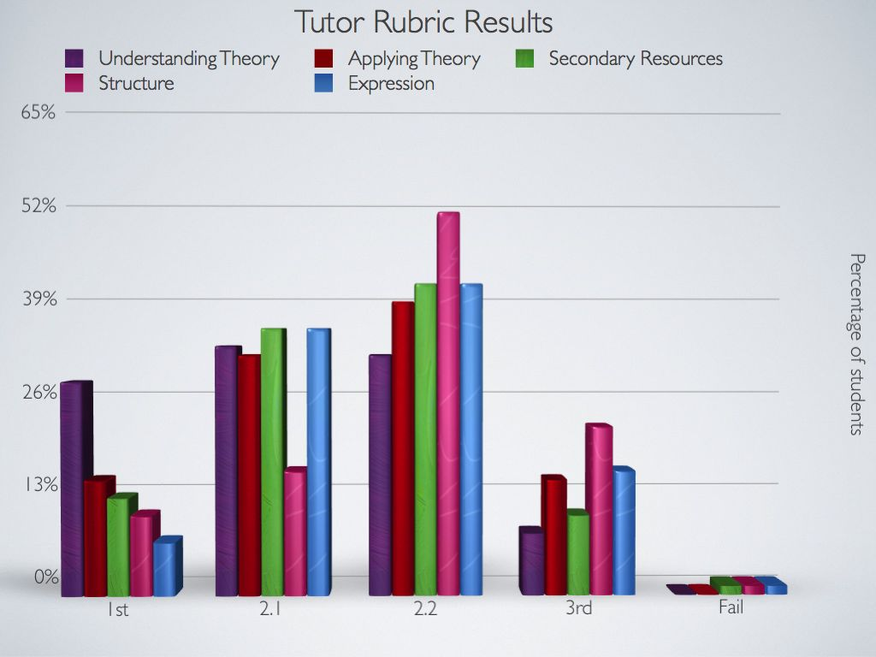

Data skills
Asking questions of data is a hugely important part of any successful analytics project. However having the skills to get the answers, and to create meaningful visualisations from data is problematic for those without any developed statistical skills. Cath admits to finding working with data challenging.
"My big headache has always been managing the data once I get it".
However, even what Cath describes as rudimentary spreadsheet skills she has been able to create meaningful graphs. The lack of data skills coupled with the lack of dedicated data scientists is something that Cath recognises as an issue for the further development of learning analytics for the whole sector, not just in her department and institution. Currently one of Cath’s Post Graduate students is working on analysing her latest data collection.
"The long term aim is to get to a point where nobody has to do any of it because it's all beautifully crunched for us by an analytics engine that then generates a dashboard that we then know what to do with, what interventions to act on having seen the data. . . but that's a while off yet"
As Cath and her colleagues explore and use their data more, they are realising the importance of reviewing and updating their data collection and entry points so they are not just analyzing data collected by default by the system. This is leading to the emergence of a more collaborative approach to the development of assessment criteria and generic feedback comments.

Using the data with students
A key part of Cath's work has focused on developing effective strategies to share data with students in a contextualized, supportive and sensitive way. To this end Cath and colleagues have been developing and running a series of student facing workshops.
In the first (pre-assessment) workshop the assignment and its assessment rubric is introduced. Using collective data from previous cohorts it is possible to visualize common errors and their impact on final marks. Once the assignment is completed and marked, a follow up workshop provides a collective view of group performance. This opportunity for students to see common mistakes and contextualize their own performance within a cohort is proving to be very motivating. One unexpected result of group sharing of common problems that Cath has noticed is in terms of acting on common mistakes,
"If students can see others have the same problem as them, then they seem to be more motivated to fix it ".
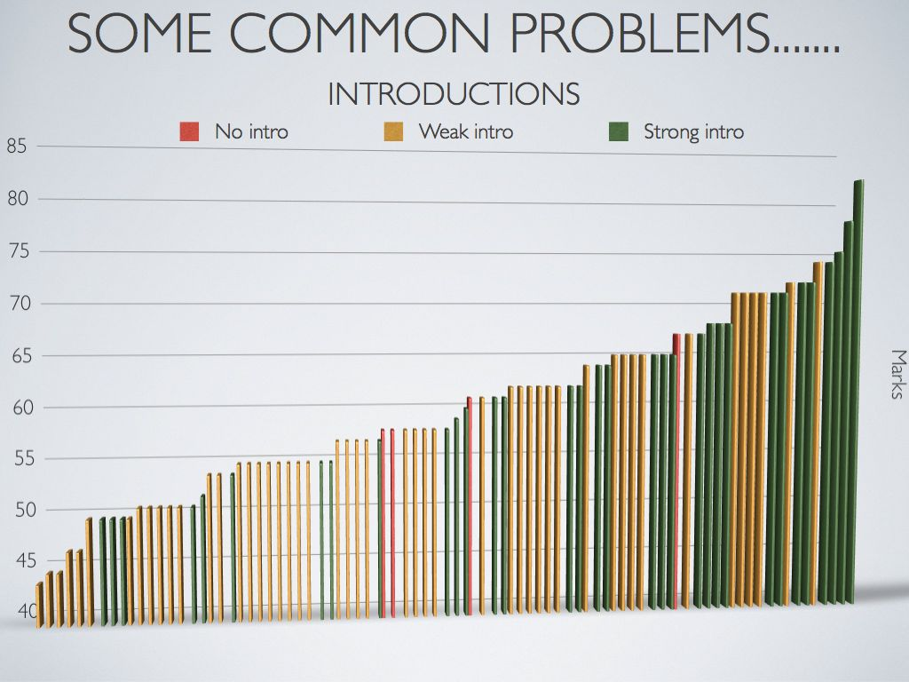
Getting assessment and feedback is an emotional experience for students so careful consideration of how, when and what level of data is shared with students is required. There could be a danger of dashboards alone being emotionally deficient. Students need to be supported to enable them to act on the analytics there are being given. Supporting students continues to be the underlying driver for the development of this workshop model.

workload
At the moment Cath recognises this kind of approach to using analytics coupled with the skills gap has generated extra workload. But already she can see payback both in terms of student performance and in the development of more collaborative approaches to assessment and overall course design:
"In the long run it will save time but I'm hoping that we get to point where a lot of this is automated. But we won't get there until we've done the testing and evaluation and can see the impact it has and what data is worth showing, when and how, and how do you support it. Unfortunately that has to be quite a manual process."

next steps
Currently the University is evaluating assessment and feedback strategies and the role of learning analytics. Part of this is work is being undertaken through the EBEAM project (part of the Jisc Assessment and Feedback Programme) that is exploring the development of effective approaches to more team-based design approaches and the development of standard generic comments and assessment rubrics. It is hoped that this work, and future collaborations, will provide a solid foundation that enables staff and students to develop effective ways to act on data to improve teaching and learning strategies and overall student success.

top tips
- Time – this kind of approach does take time and it can take several cycles before you have enough data to be useful. So take time to think about what you want to achieve, and what data you need to collect - don’t just dive into analytics.
- Design - think about design, both in terms of the design of your data entry and collection points and in terms of your overall course design.
- Review – review what data you already have.

CETIS Analytics Series

Volume 1
Vol.1 No.1. Analytics, What is Changing and Why does it Matter?
Vol.1 No.2. Analytics for the Whole Institution; Balancing Strategy and Tactics
Vol.1 No.3.Analytics for Learning and Teaching
Vol.1 No.4. Analytics for Understanding Research
Vol.1 No.5.What is Analytics? Definition and Essential Characteristics
Vol.1 No.6.Legal, Risk and Ethical Aspects of Analytics in Higher Education
Vol.1 No.7.A Framework of Characteristics for Analytics
Vol.1 No.8.Institutional Readiness for Analytics
Vol.1 No.9.A Brief History of Analytics
Vol.1 No.10. The Implications of Analytics for Teaching Practice in Higher Education
Vol.1 No.11.Infrastructure and Tools for Analytics

Volume 2
Vol.2. No.1. Engaging with Analytics
Vol.2. No.2 Acting on Analytics
http://publications.cetis.ac.uk/c/analytics

Acknowledgements
The CETIS Analytics Series was commissioned by Myles Danson (JISC programme manager) to give an overview of current thinking around analytics in post-16 education in the UK. In addition to the authors the following people have contributed to the production of the CETIS Analytics Series; Lorna Campbell (CETIS), Adam Cooper (CETIS), Rob Englebright (JISC), Neil Jacobs (JISC), Sheila MacNeill (CETIS) and Christina Smart (CETIS). Design and Artwork by:http://www.consul4design.com

About this White Paper
Title: Case Study: Acting on Assessment Analytics
Authors: Sheila MacNeill and Dr Cath Ellis
Date: March 2013
URI: http://publications.cetis.ac.uk/2013/750

Text Copyright © 2013 The University of Bolton
This work is licensed under the Creative Commons Attribution 3.0 UK Licence. For more information on the JISC CETIS publication policy see http://wiki.cetis.ac.uk/JISC_CETIS_Publication_Policy

Published by The University of Bolton

About CETIS
CETIS are globally recognised as leading experts on interoperability and technology standards in learning, education and training. We work with our clients and partners to develop policy and strategy, providing impartial and independent advice on technology and standards. CETIS are active in the development and implementation of open standards and represent our clients in national, European and global standards bodies and industry consortia, and have been instrumental in developing and promoting the adoption of technology and standards for course advertising, open education resources, assessment, and student data management, opening new markets and creating opportunities for innovation.
For more information visit our website: http://jisc.cetis.ac.uk/
This paper has been produced by CETIS for JISC: http://www.jisc.ac.uk/

http://www.hud.ac.uk/
http://www.hud.ac.uk/ourstaff/profile/index.php?staffuid=smuscae
http://www.uow.edu.au/index.html
http://library.hud.ac.uk/blogs/projects/ebeam/
http://www.jisc.ac.uk/whatwedo/programmes/elearning/assessmentandfeedback.aspx

