Beyond MOOCs: Sustainable Online Learning in Institutions

A white paper
By Li Yuan, Stephen Powell and Bill Olivier

Beyond MOOCs: Sustainable Online Learning in Institutions
By Li Yuan, Stephen Powell and Bill Olivier

Contents
1. Executive Summary 3
2. Introduction 5
3. Key Concepts of MOOC Development 6
3.1 Openness: Scalability & Connectivity 7
3.2 Revenue Model: Freemium & Premium 7
3.3 Service Disaggregation: Unbundling and Re-bundling 8
3.4 Significance 9
4. Impact on Teaching and Learning in Institutions 9
4.1 Technology Options 9
Option 1: Open up Existing VLE 10
Option 2: MOOC Platforms 10
Option 3: Use an Ad Hoc Platform to Support Innovation 11
4.2 Pedagogic Opportunities 11
4.3 Learner Choices 12
5. Implementation of Open Online Learning in Institutions 13
5.1 Strategic Challenges and Opportunities 14
5.2 Organisational Response 15
5.2.1 Mission, Purpose and Values 15
5.2.2 Strategic Directions 15
5.2.3 Capability Building Requirements 16
6. Conclusion 16
7. References 18
Acknowledgements 19
About the Authors 19
About Cetis 20

Keywords: MOOC, Open Online Learning, Business Model

Executive Summary
The key opportunity for institutions is to take the concepts developed by the MOOC experiment to date and use them to improve the quality of their face-to-face and online provision, and to open up access to higher education. Most importantly, the understanding gained should be used to inform diversification strategies including the development of new business models and pedagogic approaches that take full advantage of digital technologies.

The critical discourse emerging around MOOCs is providing an opportunity for institutions to develop a more strategic approach to online learning. This includes enhancing existing classroom teaching practices, promoting institutional reputation and developing new revenue models. There are indications that some MOOCs are becoming more focussed on corporate training, which suggests that they may not pose a immediate threat to the existing pedagogical, revenue or business models of higher education institutions (HEIs). The number of Massive Open Online Courses (MOOCs) will continue to grow with the development of credit bearing courses likely to be a trend.
The findings from this report are summarised in three sections: key themes that have emerged from the MOOC experiment, opportunities that institutions should consider exploring, and longer-term strategic considerations and likelihood that this will happen for institutions.
Three key themes emerge from the MOOC experiment:
- Openness - new approaches to online learning, including models for scalable provision that may generate revenues, and promote open learning, which goes beyond institutional boundaries through the use of online communities. [Increasing impact & long term, likely for most institutions]
- Revenue models - different revenue models taking the established ideas from technology start-ups, such as applying the concepts of freemium and premium offers into online learning, providing institutions with new ways of thinking about marketing and income generation. [High impact & medium term, more likely for institutions looking for new revenue streams]
- Service Disaggregation - experimentation with business models that include unbundling and re-bundling of courses and delivery related services, such as offering paid for assessment and/or teaching and support, on top of free online course content. This may have a wider impact across institutions in the future through better deployment of existing resources to add value to customers where there is greatest benefit and to reduce costs through outsourcing (unbundling is already happening independently of MOOCs). [High impact & short term, likely for most institutions]

Institutions should consider exploring a set of opportunities that have been brought to the attention of mainstream education by MOOCs, and experiment with new approaches for developing technology-enabled changes in teaching and learning to improve opportunities for individual learners. These include:
- Technology options - new platforms and services with different functions, terms and conditions for experimenting with the development of MOOCs and open online provision in institutions, including opening up an existing VLE, partnering with a commercial MOOC platform; or using an ad hoc collection of tools and services that are suitable for innovative experimentation. [Low impact & short term, likely for most institutions]
- Pedagogic opportunities – for educators to experiment and evaluate different online learning approaches by developing and using MOOCs that challenge the established roles of learner and teacher and offer more flexible forms of learning and assessment that include community as well as content-based models of learning. For some, experimentation will be at the level of the individual lecturer and for others it may be departmental or large-scale cross-institutional change projects. [Medium impact & medium term, likely for some types of institutions]
- Learner choices - developing new and affordable ways for learners to access courses and materials with the possibility of study for credits that are affordable and flexible. A starting point that is not based on existing courses can be a less constraining way of exploring new approaches. [High impact & short term, likely for some institutions]

Institutions are operating in an environment of increased marketisation and global competition, increasing student demand, reduced central government funding and affordability issues for students. Institutions will have to make strategic choices about how they respond to the changing contexts in which they operate; depending on the starting point these will have short, medium and long-term implications:
- Mission, purpose and values - taking full account of the significant wider changes in HEIs’ business environments that may require institutions to review how they interpret their mission, purpose and values when developing their strategic response. [Variable impact & long term, likely for most institutions]
- Strategic directions - using the new opportunities presented by rethinking MOOCs as a useful motivation for institutions to examine their current provision and think about ways in which they can change and diversify. However, failure to recognise the scale of this challenge may well derail any new strategic directions. For institutions with little experience of open and online provision, options for rapid development may be limited to forming partnerships with external organisations with the required capabilities. [High impact & long term, likely for most institutions]
- Capability building requirements - reviewing existing in-house capabilities including: technical infrastructure, academic and support staff working practices. If starting from a low base, these will require significant commitment to change and develop, in order to support new business models for online provision. [Variable impact & short term, likely for most institutions]
- Business model components - there is an opportunity for institutions to examine their current provision and think about ways in which they can change and diversify to develop new sustainable business models for open online provision that take as their starting point the needs of the learner rather than the interests of the institution. [High impact & medium term, likely for some institutions]

Introduction
The interest in Massive Open Online Courses (MOOCs) has created a context in which higher education institutions are re-evaluating their online learning provision. This is within a context of an increasingly globalised higher education (HE) system with more competition nationally and internationally for students and, in many countries the political desire to marketise HE. In the UK, since 2010 the government has sought to increase competition through the creation of new forms of public and private universities, as well as changing the funding and market conditions of existing universities. As a backdrop to these national and international trends, there is an ongoing maturing of technology, infrastructure and tools providing an opportunity for the development of new pedagogical and business models such as those presented by different forms of open online courses, including MOOCs (Yuan and Powell 2013).
It is generally agreed that the established models of higher education are costly in terms of the fees many institutions charge and the opportunity costs to students of full-time study. However, state subsidies through loan schemes (in countries such as the UK, US, Australia and New Zealand) change the perceived financial risks and the appetite for full-time, face-to-face provision remains strong. Nevertheless, there is the possibility that students would be attracted to less burdensome options if institutions were to offer more flexible approaches to study that have a lower cost of provision and hence lower fees, a possible threat to existing models. In part, this uncertainty about the future and the sustainability of the current business models in HEIs is one factor that has generated significant levels of interest in MOOCs, offering an alternative approach to online learning for tertiary level students.
The research evidence to date suggests that MOOCs may be a popular route for professional development, with 65 - 75% of students who participate already holding a bachelors level degree (Hill, 2013). This suggests that the threat to existing business models for tertiary level students may be limited. As a result, the commercial MOOC providers, such as Udacity and Coursera, have moved on to professional and corporate training, broadening their offerings to appeal to employers (Chafkin, 2013). It is still early days for MOOCs, but if they are to attract large numbers of learners who are currently unserved by the higher education system, then approaches such as credit and award bearing courses may be required with appropriate learner support. According to the Department for Innovation and Skills (BIS) report, MOOCs will challenge existing HEI’s business models, pedagogy, and international education provision (BIS, 2013). However, a report published by Moody’s Investors Service anticipates that MOOCs developed by for-profit companies will have mixed impact on online provision for different types of HE institutions (Moody’s, 2013; Kalman, 2013).
The argument that MOOCs have provided a lens through which to examine current pedagogical and business models for face-to-face as well as online distance learning, including methods of accreditation, is gaining increasing acceptance. As the BIS report suggested, further actions are needed to respond to the maturing of MOOCs, including: the exploration of a viable business model for low-cost accredited degrees; understanding the trajectory of their technical development; and opportunities around accreditation and pedagogical innovation. Whatever the future holds, there may still be significant opportunities to be exploited from MOOCs for institutions’ marketing activities and for academics to reach a wider audience.
This paper will look beyond the current debate on MOOCs to understand the potential of open online learning for learners, educators and institutions from pedagogical, financial and technological perspectives. In particular, it will identify which innovations provide an opportunity to enhance teaching and learning and also to improve current financial and business models for institutions. A concluding section provides a decision-making framework to address questions of what form or forms of online learning provision would be appropriate to meet a particular organisation’s business needs.

Key Concepts of MOOC Development
Stephen Downes and George Siemens created the first Massive Open Online Course (MOOC), CCK08, in 2008 (Downes, 2013) using freely available online services and tools. It was different to other forms of online distance learning in terms of its design intentions, which were to offer an openly accessible, scalable course around a domain of knowledge, with a start and an end date, based on connectivist principles of learning.
Loosely borrowing from the original concept of the MOOC (now labelled cMOOCs) developed by Downes and Siemens, three new major MOOC technology platforms (now labelled xMOOCs) launched in 2012, namely edX, Coursera and Udacity. They developed a business model that was to partner with elite universities to publish their courses online, for anyone interested in learning for free. This adoption of the MOOC concept is a significant departure from the original, in that as well as some of the new platforms being for profit companies themselves, some of the courses delivered also have a revenue generation motivation more in common with established, content-based, profit driven approaches to online distance learning in HE.
Table 1, MOOC Typologies, analyses and gives an overview of the different forms of MOOCs in terms of massive, open, online and course. The different interpretations placed upon the title words have significant implications for developing business models, pedagogical opportunities and technology options for each type of MOOC.
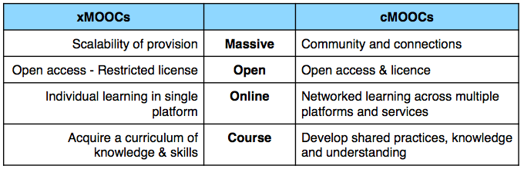
Table 1. MOOC Typologies
For xMOOCs, the word Massive focuses on the scalability with potential revenue streams while for cMOOCs it focuses on establishing learning communities and connections.
For most xMOOCs, the word Open, means open access with relatively restricted licences for content but for cMOOCs it is open access with a licence that allows content to be used elsewhere under certain conditions.
For xMOOCs the word Online focuses on individual learning, but cMOOCs emphasises networked learning.
For xMOOCs the word Course emphasises the consumption of content, whilst in cMOOCs learners are expected to engage with peers and more widely across the Internet in online communities of practice sharing resources and generating their own content.
However, it is possible that in future the two approaches will merge, offering different balances of content delivery and conversational models of learning, to address a wider range of potential participants and topics than either does at present. The significance of MOOC development for institutions involves three key areas: openness, revenue models and disaggregation of HE provision. These are further discussed below.

Openness: Scalability & Connectivity
The term openness in an educational context encapsulates a wide range of concepts including registration requirements, fees to access a course, or what may be done with resources (Downes, 2013). In the case of MOOCs, openness is key as it is this that it makes it possible to pursue the scalability of courses and the connectivity of social networked learning beyond institutions.
MOOCs based on the principles of connectivism provide opportunities for learners to network and cluster with people interested in similar topics, to create groups for collaborations that potentially last beyond the course and which may extend into or link with a larger community (Siemens and Downes, 2009). These ideas about learning through an ongoing process of negotiation of meaning within a community and through the use of the Internet, can transcend institutional and geographical boundaries worldwide. For some the motivation for delivering MOOCs can be about giving learning opportunities and exploring new pedagogy, not solely for financial reward.
For MOOCs based on a content delivery model, openness is important because it brings with it the possibility of large numbers of learners following a structured learning experience. This makes possible a revenue model that sells additional products and services through the MOOC platform and potential revenues generated through data collected. This is unfamiliar to territory for institutions, although commercial providers feel confident that they will be able to find a way to use data for profit. To achieve scalability at minimal additional cost and maintain participation, extensive use is made of video and quizzes with automatic feedback.
These two MOOCs approaches are not exclusive of each other and combinations of the two are likely to be the most effective. However, adoption of the connectivist approach is likely to require more pedagogical innovation and the need to experiment with networked learning on social media platforms. The commercial MOOC platforms offer a more straightforward approach with a focus on the scalable delivery of content and data driven business. Both developments challenge the traditional ways of teaching and learning and delivery models in universities.

Revenue Model: Freemium & Premium
Commercial MOOC start-ups are adopting what is known as a ‘freemium to premium’ business model, one that has been widely used by Silicon Valley technology and social media start-ups. The model offers services and products that are initially free, and once a consumer base has been established, a fee is then charged for advanced or additional services and products. Examples of companies that have adopted this model for their services include Google, Facebook and Twitter. Key to this approach is the level of attention generated and consumption of the free product; this provides a platform to sell premium products or services to some of the users. As the use of the free product increases, the demand for the revenue generating products increases.
In the case of xMOOCs, this approach is exemplified by the venture capitalists’ investment in Coursera and Udacity to fund the startup of their MOOC platforms. These xMOOC platform providers partner with ‘elite’ universities to offer free courses without credit. They are also working with non-elite universities and colleges to embed MOOCs into credit-based courses and degree programmes to extend the free provision. The premium model requires the MOOC start-ups to offer additional services for fees and this can include certification, licensing of course materials, and tuition fees for credit-based courses.
The MOOC platforms also partner with other commercial providers to provide relevant services to learners. For example, Coursera receives a fee each time a student clicks through to the Amazon site to buy recommended textbooks or other products. Both Coursera and Udacity also partner with Pearson to provide examinations at their test centres.

Service Disaggregation: Unbundling and Re-bundling
Christensen, Anthony and Roth (2004, 227 – 250) provide a useful perspective to help understand the concept of disaggregation. In simple terms, companies can “choose to integrate, executing most of the activities themselves, or they can choose to specialize and focus on a narrow range of activities, relying on suppliers and partners to provide other elements of value added”, (ibid, p225). According to Christensen, companies should retain direct control over aspects of their product that are the most important to their customers, and outsource those aspects of the product that are not seen to be important by customers and can be done more effectively and efficiently by a specialist company. As would be expected, there are costs and benefits associated with each approach. Integrated product and service designs allow for easier development of the whole as each of the component parts can be readily changed and developed to make improvements. However, companies that have integrated products and services “tend to be relatively inflexible” (ibid, p241) and slow to react to environmental changes.
Applying this theory to higher education, the integrated model is dominant and HEIs are responsible for the full range of activities required to deliver programmes: curriculum design, marketing, recruitment and enrolment, delivery, and assessment and accreditation. However, MOOCs represent an unbundling of the traditional services, which higher education institutions (both distance and campus) have been delivering (Universities UK, 2013, p24). For example, MOOC platforms are used for marketing, recruitment and as a delivery channel, while responsibility for the content remains with the universities. Exams may be set by HEIs, but run and supervised by third parties like Pearson Education in their testing centres. Another example of this unbundling is where one university’s courses are licensed for delivery by another institution.
It is suggested that unbundling teaching and assessment will create opportunities for learners to access higher education at a low cost and through various routes. However, it is worth noting that unbundling has been around for a long time. The University of London International Programmes, with assessment available when candidates feel ready, have existed to provide distance learning since 1858, with tuition and assessment taking place in centres around the world. More recently, organisations such as Laureate International Universities have taken advantage of the Internet to develop a network of HEIs with whom they work to offer online courses with a business model based on unbundling. This includes the University of Liverpool, which set up an online institution in 2000 in partnership with Laureate Online Education. This provides the platform, marketing expertise and the teaching team, with the university retaining final control over academic and quality matters.
MOOCs signal the continuing development of educational provision that is not bounded by limits on geography or registration requirements. If unbundling is pursued, institutions will need to identify new ways of packaging, planning and organising their courses, services and learning support activities. They can then focus on their unique disciplinary, reputational and/or geographical strengths. For example, institutions could provide contextualised local and personalised learning experience through re-bundling different components and elements from other organisations to create certificates and degree programmes that meet local demand. Some universities have started to experiment with re-bundling by embedding courses from MOOC platforms into their existing face-to-face courses. Re-bundling is a possible threat to HEIs, but also an opportunity as those institutions which re-bundle effectively may find a way to take advantage of MOOCs by incorporating them into revenue-producing degree programmes. There is also a case to be made that educational publishers such as Pearson, will make an attempt to develop new business models by applying digital publishing techniques to the HE market place.

Significance
The significance of MOOCs for HEIs has been the subject of considerable speculation in reports such as Universities UK’s Massive Online Open Courses: Higher education’s digital moment (2013); UNESCO’s Policy Briefing on Introduction to MOOCs (2013) and the Department for Business Innovation and Skills report: The Maturing of the MOOC (2013). This high level of interest is a tacit recognition of the potential of MOOCs to disrupt current university models or generate new income streams.

Impact on Teaching and Learning in Institutions
The development of MOOCs and other new forms of online provision can be considered through the lenses of technology options, pedagogical opportunities and learner choices. Each of these will be addressed in turn in this section.

Technology Options
Virtual Learning Environments (VLEs) are now widely adopted by HEIs based on the traditional formats of the course and the class in universities, which brings with it concepts of restricted access to a controlled experience. Often, the VLE is integrated with a student records system that is used for provisioning purposes, and providing student access rights. MOOCs pose a set of challenges for the existing technology and the way that it is managed in that they require access to courses for large numbers of learners. In the cMOOC model, there is the explicit requirement to design courses that make use of many and various tools and services that are beyond the control of the institution or course initiator.
MOOC developments are causing institutions to re-visit online distance learning and consider how they can better use technology to reduce costs, create efficiency in their teaching operations, demonstrate value, and reach new markets. Whether or not MOOCs become a part of mainstream provision, there is a question about the technology options that best suit a particular institution’s needs, and this may include MOOCs as well as other online distance learning provision. Technologically, there is little that is new or innovative, but the rapid development of MOOC platforms and services with different functions, terms and conditions can lead to significant levels of confusion about what strategic course of action an institution should take.
Table 2, MOOC Technologies and Key Implications for Institutions, identifies three options for those who are interested in experimenting with the development of online provision: open up an existing VLE, partner with a commercial MOOC platform; or use an ad hoc collection of tools and services that are suitable for innovative experimentation.

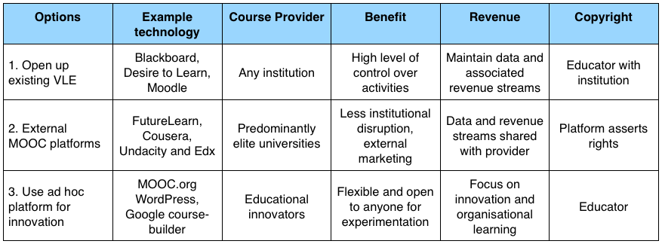
Table 2. MOOC Technologies and Key Implications for Institutions

Option 1: Open up Existing VLE
Virtual Learning Environment (VLE) vendors, including Blackboard, Desire2learn, and Moodle have emphasised existing features of their products that enable universities to offer MOOCs by relatively straightforward re-configuration. Their approach has been to market their existing products as suitable for delivering MOOCs. For example, institutions that are currently licensing Blackboard’s learning management system, Blackboard Learn, will have access to the MOOC platform at no additional cost. However, individual instructors cannot offer more than five concurrent MOOCs.
VLE providers promise to expand their services and features to facilitate not only access to the courses for unlimited number of learners, but also to provide advanced analytics, interactive multimedia, synchronous collaboration, and even integration with student support services. In this model, institutions maintain control over the course data and exercise copyright over content, including revenue-generating activities. VLE vendors allow institutions to retain full ownership of the content and deploy their own credit mechanisms that do not require institutions to create additional vendor relationships (Desire2learn, 2013).
Open source VLE tools, like Moodle, are also readily configurable as MOOC platforms requiring no additional components to be installed. Institutions retain control over their data and revenue generating activities, and depending on how their site is hosted, they will have a higher degree of control over the establishment and running of their MOOC. There will be IT infrastructures costs associated with this approach.

Option 2: MOOC Platforms
Companies such as Coursera, Udacity and the non–profit organisation, edX provide MOOC platforms as shared services to universities to run their courses for learners who are interested in studying for free or paying fees for additional products and services. The MOOC platforms are designed to be accessible to anyone at any time, and various technologies have made this kind of educational environment possible, including software that can administer and support a large number of users, gather data on student participation, deliver video footage of lectures and provide automated tests and feedback.
These MOOC platforms host courses from academics in top universities, who may or may not benefit financially, and the institutions usually maintain copyright and may choose to use creative commons licences. Platforms assert copyright of course material and user-generated content underpinned through agreements between them and their affiliates (Campbell, 2013). A key question is the arrangements for subsequent access to their course participants’ data. A significant challenge that MOOCs share with other open educational resources is the complexity surrounding copyright. This is discussed in the Educause Copyright Challenges in a MOOC Environment (2013).
Most institutions that run courses on MOOC platforms promote access to knowledge for free, using the MOOC for marketing purposes to attract students to paid provision, or experimenting with online learning without the need to make significant changes to the way their organisation operates. The cost of publishing courses on MOOC platforms varies. For example, for a university to deploy a single course using edX the initial price is around £160,000, which enables an institution to set up their ‘production studio,’ and additional courses can be added for £22,000 (Kolowich, 2013).

Option 3: Use an Ad Hoc Platform to Support Innovation
Social media services and tools can be used as platforms for delivering MOOCs. For example, the first MOOC – CCK08 – started by being primarily centred in a Moodle discussion forum. As the course progressed, interactions were scattered over many tools and technologies to create many spaces of interactions, such as Google Groups, Twitter, blogs, wikis, YouTube, and many others. ocTEL, a MOOC run by the Association for Learning Technology (ALT) delivered on an open source blogging platform with a set of additional plugins and some custom coding.
Google has committed to the development of OpenEdX, an open-source version of the edX platform that universities and educational providers can use to support their own online learning initiatives without having to install an instance of the software. Institutions retain control of their own branding, and of their relationships with their own students and other users. Data generated by particular instances of OpenEdX are solely in the control of the institutions.
In this option, educators and course developers tend to share their works with relatively unrestricted Creative Commons (CC) licenses, which grant advance permission for the public use of their copyrighted works under conditions of their choice, in addition to allowing the use of other CC materials.

Pedagogic Opportunities
MOOCs have stimulated widespread discussion around the pedagogical approaches of teaching and learning in institutions. The current dominant approach of MOOCs is very similar to established models of online distance learning and is generally based on the production of video lectures, written resources and staged e-assessments with automated feedback. However, the early MOOCs embraced the social nature of learning by valuing learners’ existing knowledge and experience in the course and using alternative pedagogical approaches and there are significant opportunities to explore this further. Table 3, Pedagogical Approaches, sets out some of the different aspects offered by MOOCs.
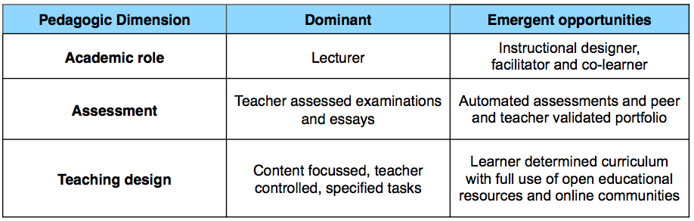
Table 3, Pedagogical Approaches
However, the nature of the experimentation undertaken will be in part determined by the institutional context. For some, experimentation will be at the level of the individual lecturer and for others it maybe at departmental or large-scale cross-institutional projects. Apart from some specialist institutions and units, the typical starting point for developing open educational resources and open online courses has been the integration of those resources into existing face-to-face courses. The notion of ‘flipped classroom’ where approaches like this can then be incorporated into existing programmes becomes an interesting possibility for innovative provision. There is a relatively high level of agreement from academic leaders in higher education institutions in the USA that MOOCs are significant way to learn about online pedagogy (Allen and Seaman, 2014).
In terms of teaching design, there are fundamental choices to be made around the extent to which a learner’s experience is controlled in terms of the activities undertaken and the subject matter covered. A design may be very prescriptive or alternatively, it may encourage learners to take a high degree of ownership and control over the skills and expertise they choose to make the focus of their study, the services and tools they use, and the learning communities, networks and individuals they engage with outside of the institution.
For assessment, there are significant opportunities to change the way that learners are assessed, to move away from examinations and essays to forms of assessment more relevant to learners including e-portfolio, peer evaluation and ‘badges’ (recognition of practical skills and achievements). If institutional credit leading to awards is part of the MOOC, then credit-bearing assessment is a difficult challenge both from the point of view of identity management if the assessment is online, and because quality and institutional reputation become relevant. However, it is an area that has been identified as needing to be addressed if MOOCs, and other forms of open courses, are to fulfil their potential. This is further discussed in section 4.3 learner choices.
The academic role as subject expert may transform to being facilitator of learning or being a specialist learning designer. There may also be a change in the learner role; the expectations placed upon them to learn collaboratively through networks that go beyond the boundaries of the institution or course that they are participating in and developing the habits of a lifelong learner, as these become more important than strategic learning aimed at passing examinations.
To make online learning successful on a massive scale will require pedagogical innovation. From the institutional perspective, the division identified in Table 3 will, over time become redundant. However, for different disciplines, subjects and markets, the pedagogy deployed will need to be tailored to the intended audience and course purpose.

Learner Choices
Within the MOOCs ecosystem and beyond, two important choices facing learners revolve around the level of institutional support they anticipate they might need for a chosen programme of study and also what they can afford. A third choice is around the recognition of their learning: are they satisfied with informal self-evaluation, or do they want or need formal recognition? Figure 2, Learner Choices, positions MOOC where they are at the moment with developments changing their characteristics along the axis depending on the different packages put together by institutions that offer greater levels of support and greater degrees of formal recognition of learning.
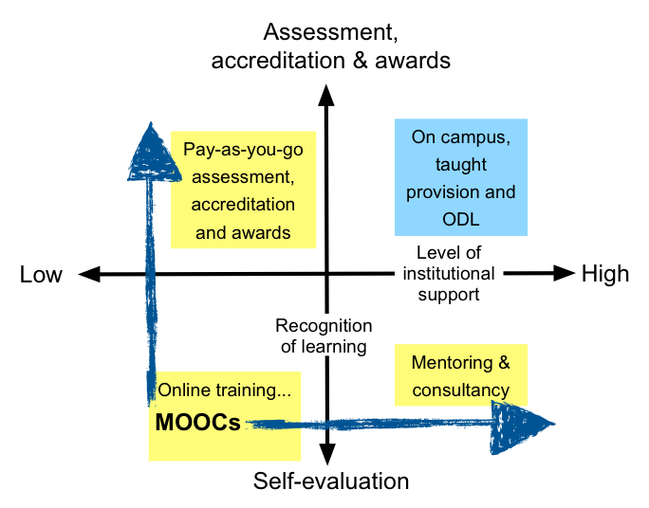
Figure 2. Learner Choices
One way to realise the potential of MOOCs in higher education, is to develop an open learning model that enables ‘pay as you go’ approaches. To appeal to a wider set of learners, a choice from self and peer evaluation by the individual through to formal recognition of learning with paid-for accreditation and awards is one dimension that HEIs are exploring. Another is intensive tuition at a variable lower cost. Learners may chose only to access open learning materials available free of charge, or additionally opt from a paid-for continuum of support including lectures, tutorials and seminars, offered online or face-to-face by universities. Along these two dimensions of accreditation and support, there are many possibilities for an individual learner to choose from (Universities UK, 2013).
MOOC platforms have also adopted alternative crediting tools including badges, certificates of completion, invigilated testing centres and third party crediting. For example, Coursera offer five accredited courses from the University of California at Irvine and Duke University, which are part of the American Council on Education’s College Credit (ACE CREDIT) scheme. This allows students to transfer credit to affiliated institutions through Signature Track. To gain credit, students need to take a supervised online exam for which they pay a fee (Coursera, 2013).
A hybrid educational model may emerge which combines online courses with competency-based crediting, and campus-based learning that offers more open, scalable, affordable and flexible higher education provision. Although the experience will not be the same as the traditional university one, for some students learning online it will be a better one.

Implementation of Open Online Learning in Institutions
Although online learning is growing rapidly in the UK higher education sector, its immaturity and relative small scale compared to mainstream provision remains a challenge to further development (HEFCE, 2010). In many universities, online learning has been seen as an add-on, or in some cases an experiment, rather than a fundamental part of the provision and mission of the institution. Since the failed UKeU launched in 2003, there have significant changes in societal adoption of technology and the maturity of the technology itself. This combined with a growing experience in the use of online learning, makes it attractive to explore this provision further.
Quality and financial viability are key considerations for making online learning programmes successful and sustainable. However, serious attention by the sector has not been given to financial and business models when developing open online learning provision. As Carey and Trick (2013) suggest, the financial benefits of online programmes depend on achieving economies of scale through either reducing the market share of others or expanding the market. They also suggest that the emerging developments in MOOCs could help improve the quality and productivity of online learning.
Higher education has remained relatively stable for many years, comprising teaching and research activities in different proportions depending on the characteristics of any particular institution. However, the financial model that supports teaching has changed significantly in recent times in countries like England and Australia, as state funding has been largely withdrawn and replaced by student fees backed by state loans. The opportunity and challenge presented by MOOCs is how to develop a viable business model that includes open online learning that is attractive to students and fits the characteristics and needs of a particular institution.
Figure 3, Framework for Assessing and Designing New Business Models, represents a starting point for identifying an appropriate strategy for the development of provision. Reading from the left, the external strategic challenges and opportunities are followed by an organisational response that in turn produces an appropriate business model. For some, this will cause an institution to review how it interprets its mission, purpose and values, especially if a new strategic direction is proposed. Even where the strategy fits well within an existing institution, it is still likely that there will be significant implications for developing a new business model. The experience of the sector is that for successful online provision to grow, substantial investment is required to develop new capabilities and/or build new external partnerships to bridge any internal capability gaps in technology, institutional processes, working practices and the development and teaching of new types of courses.
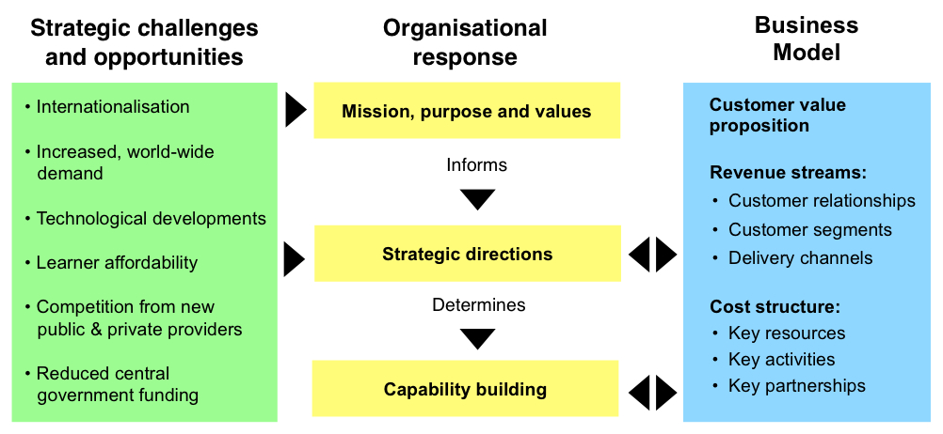
Figure 3. Framework for Assessing and Designing New Business Models

Strategic Challenges and Opportunities
Yuan and Powell (2013, p15) identify a set of drivers and trends that can be used as a list of strategic opportunities and challenges for institutions. These were adopted by the UNESCO policy brief on MOOCs (2013, p7) as setting the global context for open online provision. Globalisation, and the resultant internationalisation of higher education is something that HEIs are experiencing now, both as an opportunity for new markets abroad and as a threat to existing home markets. This ties in with the growth in demand for higher education in response to population growth and the increasing demand from lifelong learners. Additionally, increased levels of wealth provide the ability to pay for more education and economic development drives forward the demand for increasingly educated workforces. However, this is tempered by issues of affordability, particularly influenced by the terms of trade between economically developed and less developed nations. As highlighted in the introduction, the relative rising cost of higher education coupled with an economic downturn since 2008, has increased the pressure for a reduction in central government support and increased marketisation through competition as a strategy to improve efficiency in the sector. This context provides a clear opportunity for the development of new approaches that include open online learning opportunities, but there are also threats to institutions.

Organisational Response

5.2.1 Mission, Purpose and Values
The advent of MOOCs comes at a time when many institutions are trying to work out how to respond to the strategic challenges and opportunities posed by the environment in which they are operating and competing. A significant issue highlighted by the UK Universities MOOC report (2013) is, “how the development and application of online approaches require changes in the processes and procedures that underpin their mission”. The degree to which institutions respond or not to the advent of MOOCs will be determined by the characteristics of each institution and the motivations of individuals working within them. At the individual and institutional level, the institutional mission, purpose and values, and how these are interpreted, should inform the strategic direction.

5.2.2 Strategic Directions
Ernst and Young’s report on the University of the future (2012) provides a useful framework (p28) with a set of strategic questions to help identify what, at the highest level, an appropriate strategic direction for a university might be. It is widely recognised that universities (and many other organisations) can be resistant to strategic change and, necessarily built into this type of analysis, are a set of assumptions about the ability of a university to implement initiatives: “University leaders will need to find ways to stay true to the mission, maintain academic integrity and independence, and at the same time change their business and operating models” (ibid). However, as identified by Yuan and Powell (2013), for the development of MOOCs and other types of innovative online learning, new forms of organsiational arrangements may be required to separate existing from new provision along the lines explained by the Theory of Disruptive Innovation (Bower and Christenson 1995, 41-53). Christensen, Scott and Roth (2004, 198-218) attribute this, in part, to a lack of willingness to invest sufficient resources needed for the development of new and innovative products and services and to change or introduce the appropriate support processes. As Christensen points out, these decisions are made in the context of competition for scarce resources and the established values of the organisation tend to favour the incumbent products and services and the units that provision them - in many cases leading to the organisation’s demise.
Possible strategic choices based on the purpose behind the development of a MOOC or other online programmes need to be clearly articulated. These might include one or more of the following:
- Defensive - to be ready if/when MOOCs (online learning) take off.
- Offensive - to become a leader in online learning.
- Marketing - to market the university, e.g. to translate free access MOOC students into paying students, or to reach international students.
- Enhance existing provision - to provide blended learning for existing students, e.g. to develop online components for existing courses.
- Change existing provision - to focus more teaching time on two-way learning conversations with students rather than one-way lecturing the so-called ‘flipped classroom’
- Financial - to reduce teaching costs and hence the price to students.
- Research - to explore MOOCs/online learning in practice and in greater depth and become a leader in MOOC research.
Taking a strategic direction implies the need to develop corresponding capabilities as determined by the outcome desired. At an operational level, this can be captured in the components of a business model. Strategically, the significant question for HEIs is the extent to which they should rely on external partners and suppliers to provide elements of the business model (disaggregation or unbundling) that they are not equipped to do, or whether these capabilities should be developed internally in order to deliver the full-business plan.

5.2.3 Capability Building Requirements
It is important to recognise that new and innovative products and services will require organisational changes and the development of new capabilities across the organisation’s processes, technology and people. Typically, this may involve investment in additional technology, but most importantly, and often under resourced, it requires investment in the development of the workforce through training and other forms of professional development.
Business Model Canvas (Osterwalder and Pigneur 2008), which informed the third column in Figure 3. Framework for Assessing and Designing New Business Models, was developed to facilitate conversations between different stakeholders concerned with developing innovative business models. At the heart of developing the business model is an articulation of the customer value proposition, which, in this context is the course offering. This should articulate what the students are actually buying, whether this is new learning, an award, a higher education experience, training, or an affiliation with an organisation. This is particularly challenging for viable MOOCs where these move beyond a marketing function and are intended to generate revenue.
After identification of the value proposition, the business model canvas can be used to support course developers in articulating the different components that lead to establishing the anticipated revenue streams and cost structures of provision. Revenue streams are analysed from the perspective of the most important customer segments (student) for whom value is being created. What is the nature of the relationship that they want with the institution and through what channels do they want to be reached? In the context of online learning, the channels will include the Internet and mobile devices.
Cost structures are comprised of the activities and resources needed to deliver the customer value proposition, including investment in capability building, process development both educational and administrative, content development and investment in technology. Perhaps most significantly for MOOCs and other online provision, the cost structure includes the key partnerships that are required to deliver the value proposition. This could be through the kinds of arrangements that companies like Coursera and Udacity make to provide the technical infrastructure and marketing effort. In the case of online distance learning, Laureate Online Education provides a full range of services to HEIs, including the teaching support required for a course.
Prospective providers of MOOCs should keep in mind that there are many costs to take into consideration and a rigorous model is needed to estimate them and they need to be clear as to whether their involvement in MOOCs is intended to be profitable, either directly or through related channels, cost neutral, subject to a marketing cost or purely philanthropic.

Conclusion
While there is still much debate surrounding the pros and cons of MOOCs, the value of this new development requires some fundamental re-thinking in the context of developing a wider strategy for open online learning and open education. MOOCs have been useful in bringing new ideas for developing business models and pedagogic approaches to improve the quality and accessibility of online and campus teaching and learning in higher education. Coupled with the changing environment of higher education, the disruptive effect of MOOCs will be felt most significantly beyond MOOCs themselves in the development of new forms of provision that go beyond HEI’s existing markets. This has the potential to lead to greater choice for learners about how, when and what they study, but not necessarily to the detriment of existing providers. With the maturing of MOOCs and the particular maturing of online technologies in education, institutions will need a balanced provision of online and on campus solutions in order to respond strategically to the challenges and opportunities facing higher education that will emerge in the future.

References
Allen, E & Seaman J (2014). Grade Change, Tracking Online Education in the United States. Babson Survey Research Group and Quahog Research Group, LLC, http://www.onlinelearningsurvey.com/reports/gradechange.pdf
BIS (2013). The Maturing of the MOOC, https://www.gov.uk/government/publications/massive-open-online-courses-and-online-distance-learning-review
Bower, J. & Christensen, C. (1995). Disruptive technologies: catching the wave. Harvard Business Review, pp.41–53. https://cbred.uwf.edu/sahls/medicalinformatics/docfiles/Disruptive Technologies.pdf
Carey, T. & Trick, D. (2013). How Online Learning Affects Productivity, Cost and Quality in Higher Education: An Environmental Scan and Review of the Literature, http://www.heqco.ca/SiteCollectionDocuments/How_Online_Learning_Affects_Productivity-ENG.pdf
Chafkin, M. (2013). Udacity's Sebastian Thrun, Godfather of Free Online Education, Changes Course, http://www.fastcompany.com/3021473/udacity-sebastian-thrun-uphill-climb
Campbell, L. (2013) What do FutureLearn’s Terms and Conditions say about open content? http://blogs.cetis.ac.uk/lmc/2013/06/05/what-do-futurelearns-terms-and-conditions-say-about-open-content/
Christensen, C. M.; Anthony, S. D.; & Roth, E. A. (2004). Seeing What's Next: Using the Theories of Innovation to Predict Industry Change. Harvard Business School.
Desire2learn (2013). Desire2Learn offers MOOCs within its integrated learning platform, redefining the MOOC Model, https://www.desire2learn.com/news/2013/DESIRE2LEARN-OFFERS-MOOCS-WITHIN-ITS-INTEGRATED-LEARNING-PLATFORM-REDEFINING-THE-MOOC-MODEL/
Downes, S. (2013). MOOC - The Resurgence of Community in Online Learning, http://halfanhour.blogspot.co.uk/2013/05/mooc-resurgence-of-community-in-online.html
Educause (2013). Copyright Challenges in a MOOC Environment, https://net.educause.edu/ir/library/pdf/PUB9014.pdf
Ernst & Young (2012). University of the future: A thousand year old industry on the cusp of profound change, http://www.ey.com/Publication/vwLUAssets/University_of_the_future/%24FILE/University_of_the_future_2012.pdf
Hill, P. (2013). MOOCs Beyond Professional Development: Coursera’s Big Announcement in Context, http://mfeldstein.com/moocs-beyond-professional-development-courseras-big-announcement-in-context/
Kalman, Y (2013) Money Models for MOOCs, http://cacm.acm.org/magazines/2013/8/166304-money-models-for-moocs/fulltext
Kolowich, S (2013). How edX Plans to Earn, and Share, Revenue From Its Free Online Courses. The Chronicle of Higher Education, http://chronicle.com/article/How-EdX-Plans-to-Earn-and/137433/
Moody’s (2012). Shifting Ground: Technology Begins to Alter Centuries - Old Business Model for Universities, http://www.etsu.edu/125/taskforces/Programs_and_Opportunities/documents/MOOC.PDF
Norton, A (2013). The Unbundling and Re-bundling of Higher Education, http://grattan.edu.au/static/files/assets/50c8f25c/905_norton_alliance_21.pdf
Osterwalder, A. & Pigneur, Y. (2009). Business Model Generation, http://alexosterwalder.com/books.html
Siemens, G. (2013). What is the theory that underpins our MOOCs? http://www.elearnspace.org/blog/2012/06/03/what-is-the-theory-that-underpins-our-moocs/
Siemens, G and Downes, S. Connectivism and Connective Knowledge, http://ltc.umanitoba.ca/connectivism/
UNESCO (2013). Introduction to MOOCs: Avalanche, Illusion or Augmentation? Policy Brief Published by the UNESCO Institute for Information Technologies in Education, http://iite.unesco.org/publications/3214722
Universities UK (2013). Massive open online courses: higher education's digital moment? http://www.universitiesuk.ac.uk/highereducation/Pages/MOOCsHigherEducationDigitalMoment.aspx#.Us2NDfZtCDk
Yuan, L. & Powell, S. (2013). MOOCs and Open Education: Implications for Higher Education, http://publications.cetis.co.u/2013/667

Acknowledgements
We would like to acknowledge the helpful advice and comments from a variety of colleagues including Professor John Gardner (University of Stirling) and our colleagues at Cetis Lorna Campbell, Scott Wilson, Dai Griffiths and Christina Smart.

About the Authors
Li Yuan joined Cetis in 2008, after gaining her PhD in ICT in Education and working as a research fellow in the School of Education at Queen’s University of Belfast. As a Senior Researcher and Learning Technology Advisor at IEC and Cetis, Li has been involved in supporting the JISC/HEA UKOER programme and worked on the JISC Observatory to analyse and report trends in technology related innovation in the UK and internationally. She has also been involved in the EU funded “TEL-Map” project to support stakeholders to develop their shared vision and roadmaps for technology enhanced learning in the future. Her main areas of interest are around investigating and understanding emerging technology and innovative practice in education and their impact on the future of higher education. Her most recent report is “MOOCs and Open Education: implications for higher education”.
Stephen Powell is a Reader in Inquiry-based Learning at the Institute for Educational Cybernetics (IEC) and works as an Associate at Cetis. He has worked as an educator for the past 20 years, initially as a teacher in the compulsory school sector, and then in Higher Education as a developer of online programmes. He has expertise in curriculum design and delivery and the organisation of teaching and assessment and has work extensively developing work-focussed approaches to learning. Recent work has included projects developing course data analytics and the use of business modelling techniques. He has co-authored several Cetis publications including MOOCs and Open Education: Implications for Higher Education, and Institutional Readiness for Analytics.
Bill Olivier is Professor of Educational Technology at the University of Bolton and has over 25 years experience developing innovative software for education. He is a former Director for Systems and Technology in the Innovation Group at Jisc which funded a large ICT R&D programme for UK further and higher education. In that capacity, he directed the eResearch programme, ran the JISC side of the International e-Framework Programme, developed the JISC Enterprise Architecture Programme and the EU funded TEL-Map pan-European observatory. He has extensive experience in organisational and technology modelling. Bill was the co-founder of Cetis and co-director for seven years.

About this White Paper

Title: Beyond MOOCs: Sustainable Online Learning in Institutions
Authors: Li Yuan, Stephen Powell and Bill Olivier
Date: 21/01/2014
URI: http://publications.cetis.ac.uk/2014/898

Text Copyright © University of Bolton 2014
This work is licensed under the Creative Commons Attribution 4.0. http://creativecommons.org/licenses/by/4.0/

About Cetis
Cetis is the Centre for Educational Technology, Interoperability and Standards. Our staff are globally recognised as leading experts on education technology innovation, interoperability and technology standards. For over a decade Cetis has provided impartial strategic, technical and pedagogical advice on educational technology and standards to funding bodies, standards agencies, government, institutions and commercial partners.
Cetis are active in the development and implementation of open standards and have been instrumental in developing and promoting the adoption of technology and standards for course advertising, open education resources, assessment, and student data management, opening new markets and creating opportunities for innovation. Our work includes a wide range of activities from representation at national standardisation bodies, facilitation of online and face-to-face events to production of a range of formal and informal publications.
http://www.cetis.ac.uk

